[](https://www.google.co.uk/url?sa=i&rct=j&q=&esrc=s&source=images&cd=&cad=rja&uact=8&ved=0ahUKEwjbiMXpg7jTAhVGVRQKHbjfDIwQjRwIBw&url=https://www.police.uk/cheshire/&psig=AFQjCNEzLSWuiO71wfrF4W0Hnf5z_Cq86A&ust=1492949335238221)

To Parents/Carers,

Children and young people are using the internet more during lockdown so it is very important that you monitor what games, apps and websites they have access to.

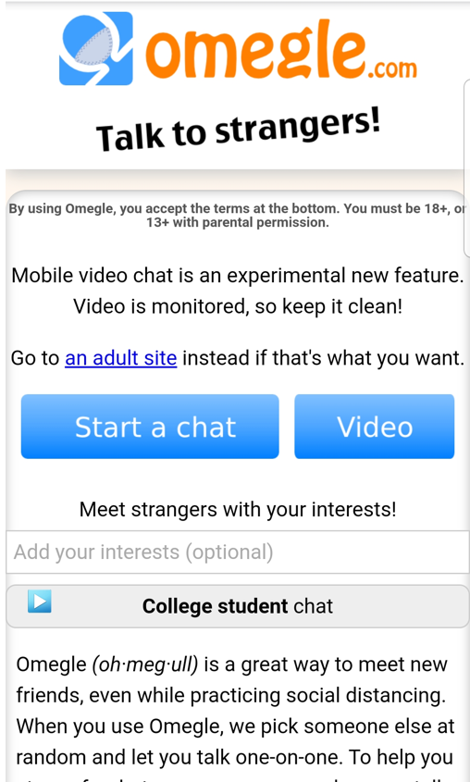

**Warning -**

Omegle has been around for some time but we have recently received reports of the site being used by children. This site allows you to talk to unknown individuals and access adult content.

**Top tips for gaming and using apps such as tik tok -**

* Explore parental controls on games consoles and other devices.
* Familiarise yourself with the blocking and reporting functions on games and ensure your child knows how to use these.
* Learn about PEGI age ratings and the PEGI content descriptors.
* Understand how to change privacy settings
* Understand how to turn location settings off
* Talk to your child regularly about gaming and their online activity. Reassure them that they can always talk to you about anything that makes them feel uncomfortable; this could be game content or something they’ve heard when chatting to other users.
* Report anyone who is acting inappropriately online.

How much do you know about the app?

## What exactly is TikTok?

* TikTok users can make their own short videos on the mobile app, and often like to have music accompany their videos. The users have creative control over the videos.
* Other TikTok users can ‘react’ to videos they see by filming their responses alongside the original video; or ‘duet’ by making a video alongside another video.

## How TikTok works:

* People aged 13 and over can download the app which has a 12+ rating in app stores - though, as, with other age-restricted platforms, parents need to ensure their children are the appropriate age to use TikTok.
* After downloading the TikTok app, users can start creating their own videos or watch content created by other users.

## Are there privacy settings?

* The app has come under fire for a lack of privacy settings in the past but users now have privacy options, including the ability to make their accounts private; choosing who can comment on or download their videos, and who can duet with them. Users can also block other users. Messaging on TikTok has always been private and messages can only be sent between friends.
* Recently, TikTok introduced a new feature that lets users filter comments by using up to 30 words that they can choose themselves. By activating this, users can make sure no one can post comments under videos using words they find unpleasant or harmful.
* All of these options can be found on the top right of the screen (three dots) inside the ‘Privacy and Settings’.
* You can look at TikTok’s safety videos to learn more: [@tiktoktips](https://www.tiktok.com/share/user/6598209972340146181?language=en&u_code=d3aa3lh71dc3g4&timestamp=1558515204&user_id=6628166048078594053)

Please see the below links for useful websites to learn more about keeping your children safe online.

#### <https://www.thinkuknow.co.uk/>

#### <https://www.ceop.police.uk/safety-centre/>

#### <https://www.nspcc.org.uk/preventing-abuse/keeping-children-safe/online-safety/talking-your-child-staying-safe-online/>

I hope that you have found this information helpful.

Kind regards,

#### PCSO Beth George