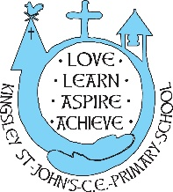
Our Curriculum
‘Believe in the light, while you have the light so that you become children of light’ John 12:36

As a Church of England Primary School we ensure that the teaching of Christian Values is embedded throughout our curriculum and an integral part of our school day. Personalising learning is a fundamental aspect of learning and teaching at Kingsley St John's.
We want our curriculum to:
- Together, as KSJers, we foster a LOVE of learning – for all God’s children. No-one in our school is afraid of making mistakes – this is seen as part of the learning process. Building resilience is a key skill within our curriculum offer and delivery.
- Our school curriculum is well thought-out and built to ensure a broad and balanced programme from which to LEARN. Throughout the school year, there will be whole-school themed skill weeks with a focus on developing key skills in an identified curriculum area, or specific curriculum days.
- ASPIRE our children to strive to do their best, reach their potential and approach their learning in a manner that is best for their unique selves. Children need to discover their own light (talents, skills and values) and nurture, embrace, celebrate and share them.
- Children at Kingsley St John’s, without exception, flourish and celebrate what they ACHIEVE. We believe in executing the highest standards in all areas of development for our pupils. This is why a significant aspect of our value for money outcomes are used to ensure the highest standards of teaching and learning.

Our curriculum is well thought through, meets our school context and embraces our location in Cheshire, Britain, Europe and the world.

