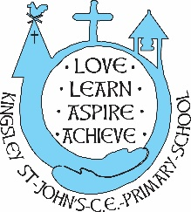

KSJ Fortnightly Flyer

*‘Believe in the light, whilst you have the light, so that you make become children of light.’*

John 12.36

Dear Parents/Carers,

Please find our fortnightly flyer, with our latest news.

**Children’s reading**

Pupils’ achievements in reading continues to be very good and higher than National Average. Our Year 6 reading for 2022 was 85% reaching the expected standard. We continually strive to ensure that teaching and learning is always developing.

Class teachers expect children to read at home with a target of at least 3 times a week. There isn’t. asset day for children to change their books, but can visit the book area any day to change their book as needed.

As they grow in fluency and confidence, children are encouraged to read with independence and are asked to keep a record in their reading diaries. Times are made in class for the teacher to have a 1:1 conversation with your child about their reading. Children should be encouraged to bring their reading journals into school each day. We would ask parents to monitor these too and sign and add a comment if you wish about your child’s attitude to reading.

**Harvest Service**

The children visited St John’s Church this week to take part in our Harvest Service.

Robins sang and acted Big Red Combine Harvester.

Sparrows shared a harvest song.

Barn Owls shared their Barn Owl Café and

Falcons shared with us the story of Naomi, Ruth and Boaz.

We shared some Autumn Hymns and Reverend Ron made us laugh and think about how far our food travels and how many people help us to get our food.

A special mention for our Year 6 girls who led the singing and William McWaters for his positivity and wonderful singing, which lifted us all.

**Governor of the Month**

This year we will enjoy a Governor of the Month programme. October is the month for Bruce Waddell, dad to Torin (Year 5). Bruce will visit school in October to talk to the children about Desmond, our school dog. He will use these discussions to review our risk assessments.

**Sporting News**

Barn Owls will enjoy a Tag Rugby training session next week with Mandy, our Sports Coordinator. Some of the Barn Owls will then be invited to a Tag Rugby competition at Helsby Rugby Club.

Article 31 of the UN Convention of the Rights of the Child states that all children have the right to rest and leisure and enjoy recreational activities.

Miss Byrne and the Sports Council are continuing to monitor and plan enhancements to our playtimes.

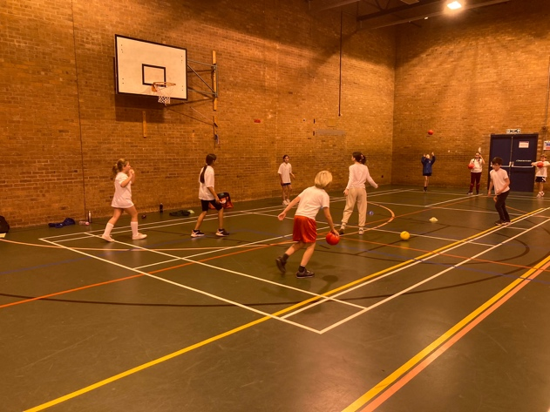

**Christmas Early Preparations**

Our Christmas Performance this year will be Countdown to Christmas. Early preparations are being made looking at roles in the play. As usual, there will be a pleasant mix of drama, song and dance. There will be no need for any parents to provide anything for the performance. Our provisional dates for the performances are December 5th – dress rehearsal pm, Tuesday 6th in the evening and Wednesday 7th in the afternoon.

Cauliflower Cards – the children are finishing off their Christmas cards this week and will be bringing them home in the next few days. If you wish to order cards, wrapping paper, tags or mugs, please complete your order online – using the code on the form sent home. YOU MUST THEN RETURN THE ARTWORK TO SCHOOL. THIS MUST BE RETURNED BY November 1st 2022.

**Contacting the Class teacher**

Please remember that for any worries, concerns or difficulties you should contact the class teacher in the first instance. The emails are always available on the class page on the website, but added here for your information

Class 1 – [cowell@kingsleystjohns.co.uk](mailto:cowell@kingsleystjohns.co.uk) or [raynor@kingsleystjohns.co.uk](mailto:raynor@kingsleystjohns.co.uk)

Class 2 – [Byrne@kingsleystjohns.co.uk](mailto:Byrne@kingsleystjohns.co.uk)

Class 3 – [senco@kingsley-st-johns.cheshire.sch.uk](mailto:senco@kingsley-st-johns.cheshire.sch.uk)

Class 4 – [davies@kingsleystjohns.co.uk](mailto:davies@kingsleystjohns.co.uk)

**Enriching our Curriculum**

As you know, we are very proud, as a school, of the breadth of ways that we work to enhance and enrich our curriculum. Some further examples this term…

Barn Owls visited The Great Orme last week and had a fabulous day out there learning about the Bronze Age.

Years 3 to 6 will have a visit to the cinema on Tuesday 22nd November

Mad Science – thank you for the really positive response to the club offer. This club will go ahead and will begin on the 8th November.

**WWF**

A small group of keen naturists in Barn Owls are very keen to adopt another endangered animal through the WWF Scheme. They have requested permission to raise awareness and funds to enable this to happen. They are working very hard on a school magazine full of information about endangered animals. School have agreed to fund the printing of this so that they can be sold to families who want to support them in their enterprise. More news to come on this shortly, well done to Pippa, Joey, Charlie and Nathan.

**Courageous Advocacy**

I would like to thank a couple of children who have stood out in recent weeks for their attitudes and decision making.  
Jonah Burge, one of our Eco-committee members brought his litter picking tools to school last week. He collected litter from Kingsley Streets on his way to school and spent his playtime and lunchtimes collecting litter and encouraging and inviting others to take part too. Charlie Lee has shown significant maturity and forgiveness following a very tricky situation for him. A big well done.

**United Nations Convention for the Rights of the Child (UNCRC)**

A year ago we started our journey to becoming a Rights Respecting School and successfully achieved our Bronze Award. As we work towards our Silver Award, we have re-affirmed our commitment to understanding and promoting the Charter of Children’s Rights. We have talked with the children about the Rights and also the responsibilities we have as citizens to ensure these rights are protected. October leads to our focus on Article 30 and Article 2 – we will be celebrating Black History Month during October. In our assembly this week, we focused on why we should be proud of ourselves and our uniqueness. We appreciate the uniqueness and positive contributions of African and Caribbean figures in our history.

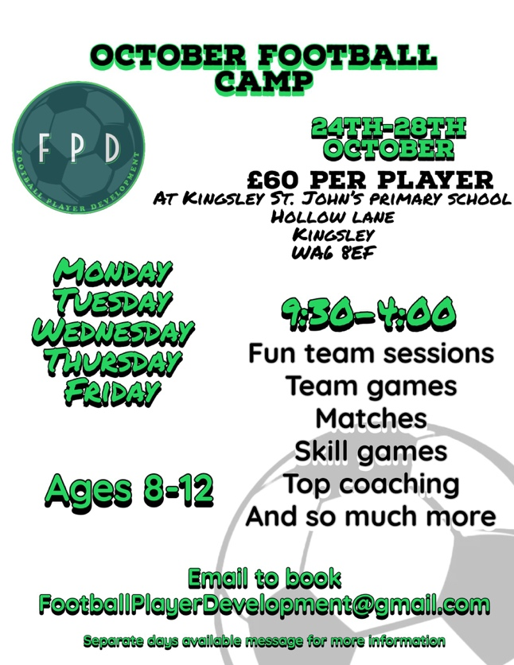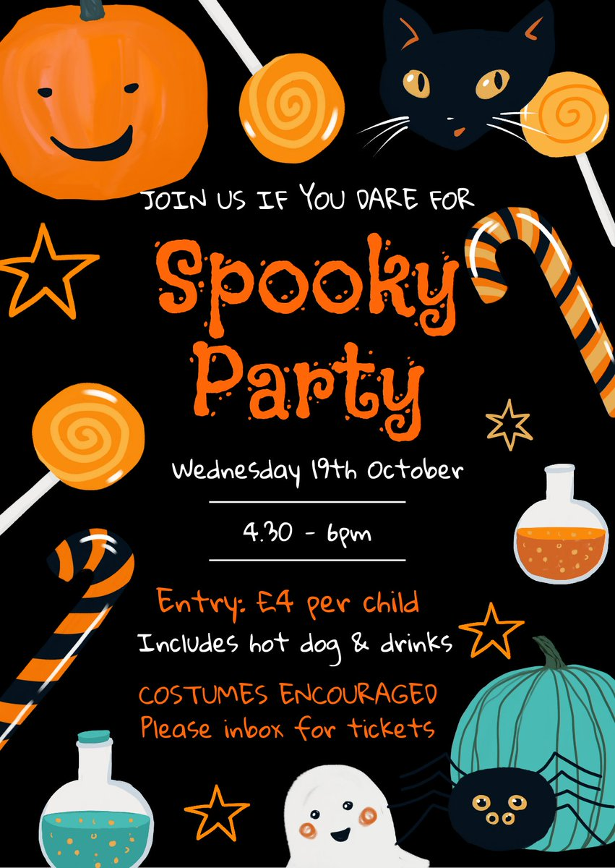

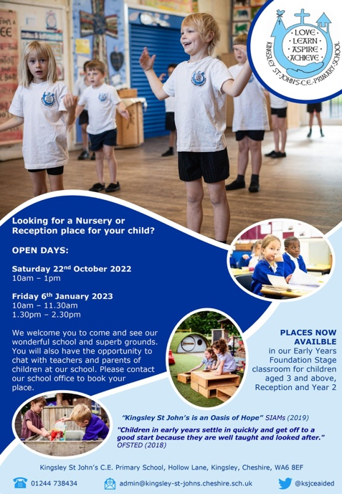

Thank you for your continued support, trust and togetherness.