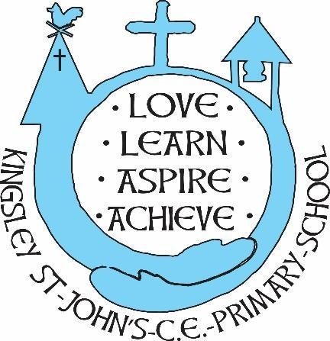
Kingsley St. John’s Maths Curriculum
We believe in God as the great creator of all things - earth, day and night, seas and oceans, animals and plants and mankind, in his own image. We believe that we all have that same seed of creativity, difference and diversity within us. At KSJ we nurture each and every seed. Regardless of background or vulnerability, our children are given all they need to grow, flourish and be the best that they can be.

Intent
At Kingsley St John’s CE Aided Primary School, we want our children to recognise the importance of maths in the wider world and the impact it has on their lives. Our Maths curriculum uses the National Curriculum and challenges the children to use a range of skills and devices confidently across a variety of problems and contexts. Our approach builds on maths concepts in concrete, pictorial and abstract representations, allowing the children to be secure in their understanding, allowing them to be mathematically fluent and able to problem solve. We aim to guide the children in explaining their reasoning and understanding using the correct mathematical language. Children are supported to work independently, developing mental strategies (as well as written), broaden their vocabulary and gain a secure knowledge base across the maths curriculum. We intend for every child to access the learning, develop their skills regardless of their ethnicity, gender, class, ability, disability or background.
Implementation
- Maths is taught following The National Curriculum
- Teachers create a positive attitude to maths learning within their classrooms;
- Maths will be taught in planned sequences with a mastery focus at the forefront of planning, using a personalised approach to deepen knowledge when needed.
- Planning will follow First 4 Maths yearly overviews for each year group. The objectives and structure of the year will be aligned with White Rose Maths planning and resources to give staff consistency in their delivery.
- Lessons will use a clear concrete, pictorial and abstract approach.
- Concrete materials and real life experiences built into lessons to reinforce maths in everyday life will help introduce new concepts.
- Teachers use precise questioning in class to test conceptual knowledge and skills, and assess pupils regularly to identify those children with gaps in learning, so that all pupils keep up.
- We build upon the knowledge and skill development of the previous years. As the children’s knowledge and understanding increases, they become more proficient in selecting and using appropriate methods of calculating problems.
- Regular events, such as maths week, allow all pupils to come off-timetable, to provide broader provision and the acquisition and application of knowledge and skills.

A mathematical concept or skill has been mastered when a child can show it in multiple ways, using the mathematical language to explain their ideas, and can independently apply the concept to new problems in unfamiliar situations. Children will gain confidence in tackling mathematical problems, using their reasoning and marks/ formal methods to support their understanding.

Impact
- The children at KSJ will be mathematical literate and use mathematical language freely across their day.
- The practical approach at Kingsley St John’s results in a fun, engaging, high-quality and meaningful maths education that provides children with the foundations and knowledge for further education and beyond.
- Through various workshops, high school competitions and visits, children have the understanding that maths has value in our lives.
- A mathematical concept or skill has been mastered when a child at KSJ can show it in multiple ways and can independently apply the concept to new problems in unfamiliar situations.
- There is clear progression in knowledge, skills and understanding within maths.

