Reading Progress Guidance

Baseline Assessments

Children in Years 1 -6 will have a reading assessment completed in September, January and June using the Lexplore reading assessment Tool. Reading ages will be recorded, outcomes analysed and interventions prioritised. Standardised scores will also be recorded so that appropriate challenge is channelled into planning, teaching and learning.
Benchmarking is also completed in September, December and February – other times as required if there are spikes in reading attainment (AfL). Benchmarking up to Green book band is completed using the new benchmarking texts. Beyond Green level is completed using the PM Benchmarking system.
Benchmarking is used to ensure appropriate challenge, monitor progress and inform teaching.
Children who do not meet the year 1 phonics screen check, will be carefully monitored and supported with interventions throughout year 2. Pupils working below the expected level in Y3+ will be monitored carefully using phonics interventions and precision teaching.
Children who do not meet the Year 4-5 outcomes for reading will receive daily reading support within year 1.

Teaching and Learning of Reading

In the early years there is a clear and systematic approach to the teaching of reading. High quality texts are used to support the EY Curriculum. Super Six story texts are in the environment to support the themes of learning. Terrific ten poems, rhymes and songs are selected per theme also. There are daily opportunities to sing and recall rhymes, there are daily opportunities to listen to stories. Nursery pupils are encouraged to take home books from the library to share with parents/carers. Reception children have a clear routine of progress for taking home their own reading books. There are clear high expectations for progress throughout EYFS.
Nursery children have plenty of opportunities to access phase 1 phonics – environmental sounds.
Reception complete phonics learning daily, phase 2 and phase 3. There are also daily reading opportunities to ensure that knowledge and recall of sounds are securely applied. Pupils in KS1 are listened to read at least weekly, but teachers monitor reading through supporting the changing of books and monitoring reading records.
Once children are secure at Lime reading level, they move onto Beyond lime (books with a ZPD below 4)
KS2 pupil books (free reader books) are graded in line with the accelerated reading programme. Teachers are able to monitor pupil reading choices to ensure appropriate challenge and that children don’t coast with easy readers, or grow frustrated with books that are too challenging. Pupils in KS2 that continue to access the book band schemes are identified as targeted support readers within their class and their reading development is tracked closely.

Guided Reading at KS2 takes on the form of a selected text (usually in line with the Pathways to Write Programme) which is studied as a whole class guided reading text, there are opportunities to teach and practise higher order reading skills of inference and deduction, authorial intent and vocabulary choices. A third guided reading session looks at an alternative text type – song, poem etc! This develops a holistic approach to reading and an enjoyment of a wider range of texts and genre stylistic features.

Guided reading at KS1 and EYFS continue to be in line with benchmarking levels – looking to work in the level above to support challenge. Guided Reading texts are organised across all book band levels.

Reading texts form a basis for all writing units of work across the school. High quality texts support the English curriculum and cross curricular areas too.

Each class also has an enjoyable text - similar to the Pathways text to support pupils enjoyment of listening to stories read to them. This is highly valued by the teachers and the pupils. There are also elements of democracy included as children may take a vote to select the text where there are appropriate choices.

Staff model the joy of reading throughout school and our school library is well cared for and arranged to encourage new reading as well as favourite authors.

Progression through Reading

A guide to how reading progresses at KSJ.
YN and early YR | Lilac level | Wordless books, or family favourites to take home and be read by a parent – to foster a love of reading and the excitement of changing your book.
YR equivalent | Phase 2 Pink  Phase 3 pink  Phase 3 Red | Linked to phase 2 phonics and beginning to access phase 3
Y1 equivalent | Phase 3 Red  Phase 4 Red  Phase 4 Yellow  Phase 5 Blue | Linked to phonics phases
Y2 equivalent | Green Level  Orange Level  Turquoise level  Purple level  Gold level | Developing other aspects of reading – reading on for sense, picture clues, re-reading, using knowledge, understanding events and characters etc!  Building fluency
Y3 equivalent | White level  Lime level  Beyond Lime | Developing fluency and understanding  Building confidence, recall, linking parts of the text and predicting.
Y4 equivalent | ZPD 3.5 – 4.5 | Now free readers but monitor ZPD selections for appropriateness and challenge
Y5 equivalent | ZPD 4.6 – 5.9 | Now free readers but monitor ZPD selections for appropriateness and challenge
Y6 equivalent | ZPD 5.0 – 6.9 | Now free readers but monitor ZPD selections for appropriateness and challenge

Zones of Proximal Development
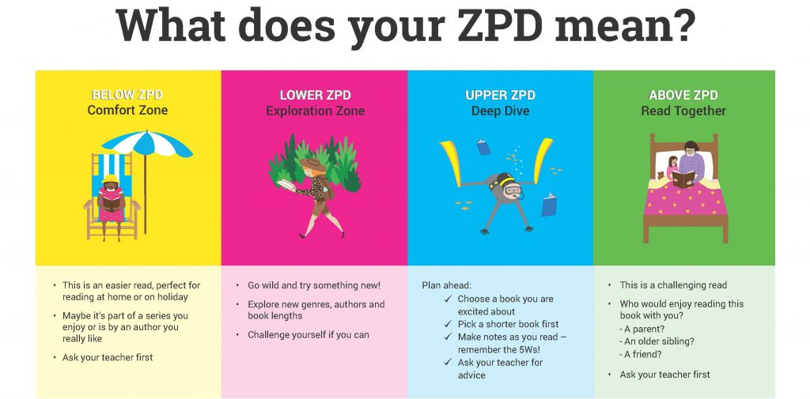

Reading age | ZPD
8.06 – 8.11 | 3.5 -3.9 | Reading below your ZPD means you will find it easy to read.  Reading above your ZPD will be a challenge and may be suitable to read with an adult together.  Aim to choose books within your ZPD.
9.00 – 9.05 | 4.0 – 4.5
9.06 – 9.11 | 4.6 - 4.9
10.00-10.11 | 5.0 – 5.9
11.00+ | 6.0 – 6.9
12.00+ | 7.0 – 7.9
13.00+ | 8.0 – 8.9
14.00+ | 9.0 – 9.9
15.00+ | 10+

How do classes log what children are reading?
All pupils have reading diaries – these are strongly encouraged to be brought into school each day. As children develop their reading independence, they are encouraged to log and record independently their reading and their thoughts about the book.
Teachers will check these and monitor reading at least weekly. If children do not bring them in to school for over a week, the class teacher will ensure that they listen to the child read on a 1:1. Contact home will also be made to encourage this to be brought into school asap.
For early reading, classes have a reading folder – in this they will record benchmarking outcomes, monitoring of 1:1 reading opportunities across the week. This is in place for all children who are accessing the book band structure.
Once children are free reading – teachers will monitor their reading records and keep a log of book choices and the ZPD stage. Teachers will converse with children about their text choices, favourite authors and themes of the book chosen. Reading is a positive experience in our school.

AR Programme
All books in the free read programme and school library are checked against the Accelerated Read Bookfinder link. https://www.arbookfind.co.uk/default.aspx
They are then given a metallic sticker and the ZPD is written in the front of the book.
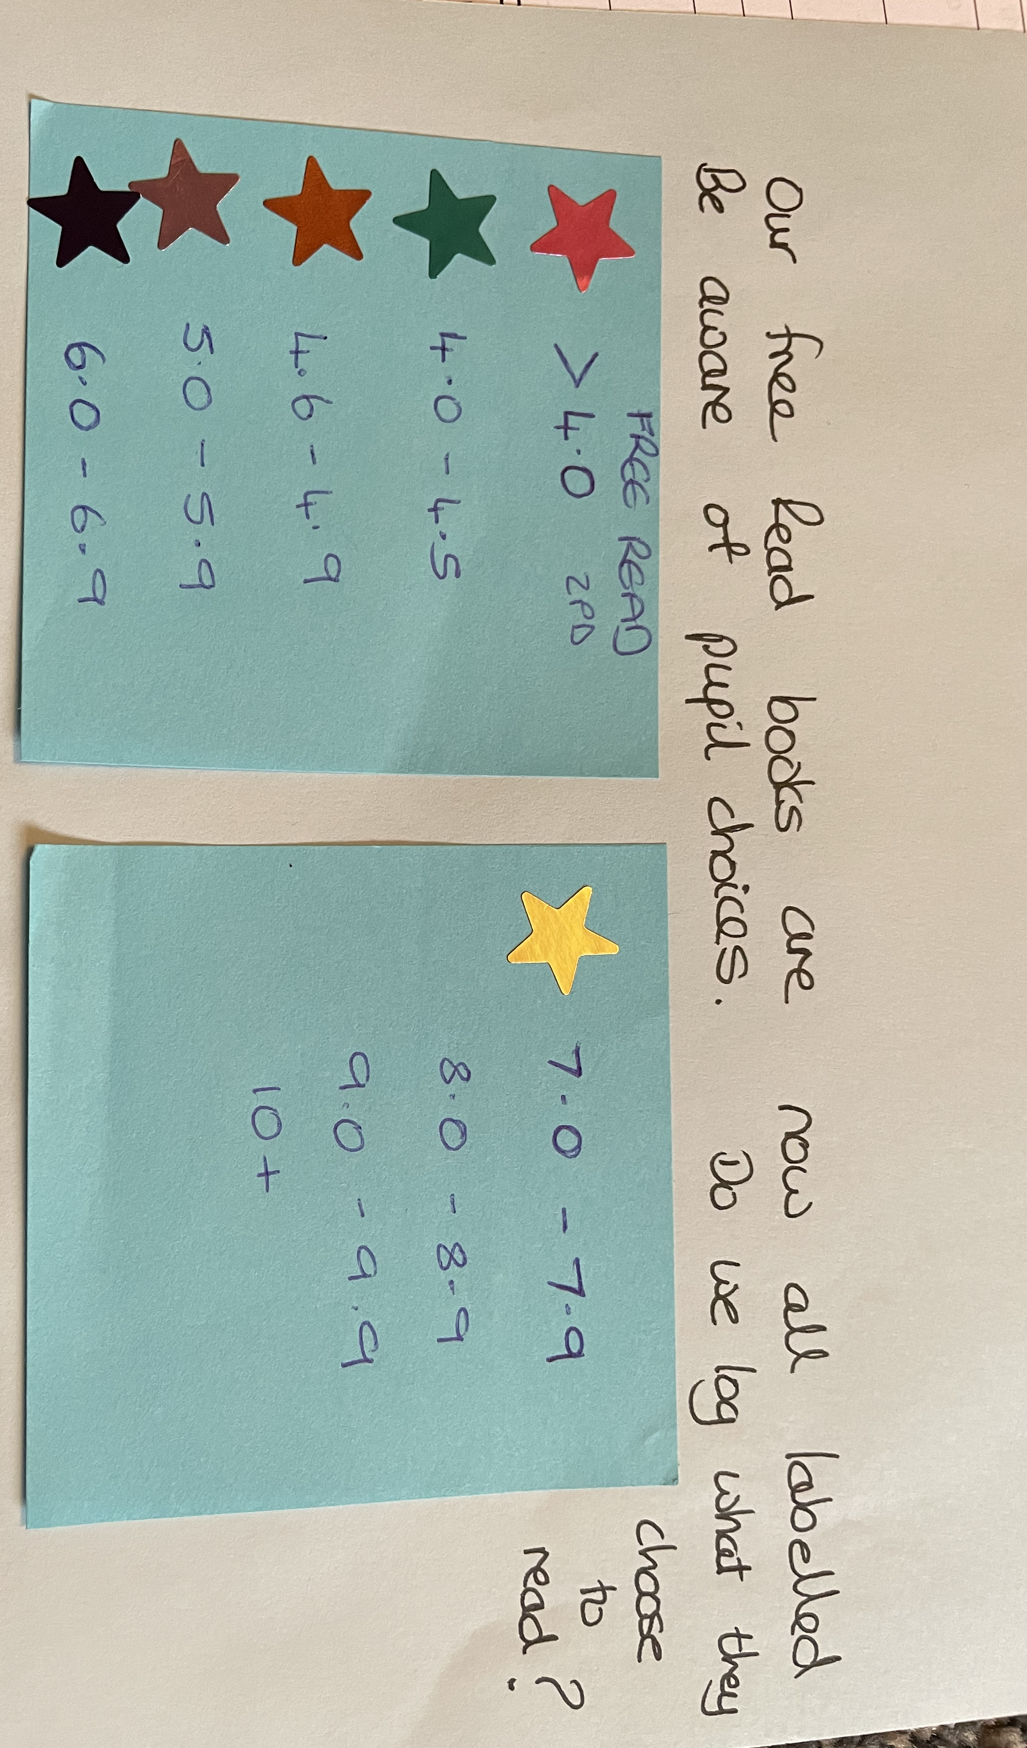
Teachers record a pupils ZPD and monitor book choices.

A Reading Environment at KSJ

Reading is highly valued across our school, baskets of books, inviting readers is in evidence in all areas of school.
In Classrooms, teachers ensure that their reading areas are inviting, inspiring and well organised for the pupils to select a text. Displays are enhanced with rich texts to support links.
The main library ensures there are cross curricular links, identifying key texts from around the world, grouping books by author or subject, poetry texts, multicultural texts, PSHCE texts, understanding our world and its history and places, Scientific books, Christian and multi-faith texts, sporting texts and expression and creative art-based texts. There is a strong balance of fiction and non-fiction. Our book collections are aimed to be displayed in an organised and welcoming style. There is evidence of progression in reading through the books that adults select for the classroom.
Children are invited to change books through the educational library service too.
