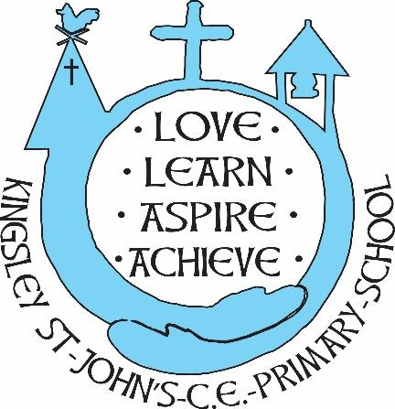
Kingsley St. John’s Writing Curriculum
We believe in God as the great creator of all things, and since God created mankind in his own image, we believe that we all have that same seed of creativity within us. At KSJ we nurture each and every seed. Regardless of background or vulnerability, our children are given all they need to grow, flourish and be the best that they can be.
Intent
Writing is a privilege and a powerful tool to communicate. At Kingsley St John’s we aim to inspire our children to express their thoughts and ideas and to communicate effectively through writing. The skill of writing is appreciated, and teachers model writing to the children and demonstrate the processes of writing to analyse and evaluate, making valuable and considered language choices for the right effect on the reader. We are all writers. We aim to harness and nurture writing skills so that oiur children can write effectively for different audiences, in different genres across the curriculum.
We aim for all children:
- to write with confidence, clarity and imagination
- to understand how to write in a range of genres in fiction and poetry,
- to use some of the structures of narratives in relation to setting, character and plot
- to write non-fiction texts, using the features of different forms to plan, draft, revise and edit, and sometimes publish their own writing
- to learn how to critically and constructively appraise the writing of themselves and others
- to develop a technical vocabulary through which to understand and discuss their writing to develop their imagination, creativity, expressive language and critical awareness through their writing
- to write using standard English
- to write with accurate technical skills
- to enjoy writing to engage and inform the reader
- to be ready for the next stage of their learning journey
- to develop their independence and own style of writing
- to select considered and thoughtful language choices.
Implementation
Writing is taught using Pathways to Write as a basis of curriculum organisation. This is adapted and personalised for the needs of the pupils to ensure there are repeated opportunities to write at length. Units are taught in a mixed age format, ensuring the relevant expectations are clear for their year group.
In Reception, we also teach writing through Pathways to Write units but constructed against the reformed Early Years Foundation Curriculum and Development Matters 2021. The units have been developed specifically to support children on their writing journey towards the Literacy Early Learning Goals.
Each unit is driven by a high quality text which our wider school curriculum is then linked to. We particularly understand how reading and writing are intrinsically linked - our reading sessions supplement the texts used in English lessons; reading skills are re-enforced in writing sessions.
By taking a text-based approach, we give the children the chance to develop culturally, emotionally, socially and spiritually, enabling them to both acquire knowledge and build on what they already know.
There are 6 half termly units per year group with a wealth of writing opportunities in each. There is a heavy emphasis on vocabulary learning and contextualized spelling, grammar and punctuation.
There is a clear sequence of learning, leading to two extended pieces of writing per half term: a narrative and a non-fiction piece.

Impact
Children at KSJ select ambitious and effective vocabulary to develop mood within their writing.
There are opportunities to demonstrate their writing skills across the curriculum.
Children can write with fluency in order to communicate.
Children understand the purpose of drafting, editing and polishing and presenting their ideas through writing.
Children are ready for the next stage of their education.
Children can spell and apply their phonic and spelling knowledge to communicate effectively in writing.
Teachers will measure progress through regular assessments of independent pieces of writing.
Teachers will analyse assessment to identify gaps , inform planning, or encourage greater understanding of key areas.
Teachers plan time for pupils to check, edit and correct own writing – or through peer assessment

