Kingsley St. John’s Design and
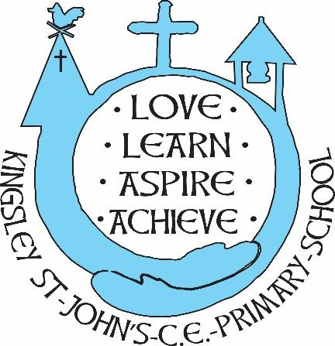
Technology Curriculum
We believe in God as the great creator of all things - earth, day and night, seas and oceans, animals and plants and mankind, in his own image. We believe that we all have that same seed of creativity within us. At KSJ we nurture each and every seed. Regardless of background or vulnerability, our children are given all they need to grow, flourish and be the best that they can be.

Intent
At Kingsley St John’s CE Aided Primary School, we want our children to be curious, imaginative and creative learners. The practical nature of Design and Technology allows pupils to design and make products while considering their own and others’ needs. Our Design and Technology curriculum uses the National Curriculum and allows pupils to investigate, question, experiment and evaluate while solving real and relevant problems. Children are supported to work critically, understanding how Design and Technology impacts on everyday life as well as the wider world as well as developing key skills and broadening their vocabulary. Pupils learn how to take risks and become more resourceful while drawing upon their experience of Science, Art and Maths. We intend for every child to access the learning, develop their skills regardless of their ethnicity, gender, class, ability, disability or background.
Through Design and Technology experiences pupils:
- are encouraged to develop enthusiasm, curiosity and creativity about the world around them
- develop skills appropriate to their age and experience
- become confident and competent using newly acquired knowledge, concepts and skills in their own independent investigations
- develop a positive attitude towards technology
- understand that the process of enquiry and investigation lead to new ideas
- have an ability to communicate their ideas verbally and in written form
- have the initiative to work independently, cooperatively and collaboratively
- have the ability to recognise Design and Technology across the curriculum and in real life
- have an awareness of inventors, designers and engineers who have impacted life locally, nationally and worldwide, historically and recently
- understand the importance of nutrition

Implementation
- Design and Technology is taught on a 2 year rolling programme based upon The National Curriculum
- Planning involves teachers creating high quality, engaging lessons with activities which enable pupils to investigate, plan, make and evaluate.
- Children will have opportunities to work individually, pairs and small groups
- We build upon the knowledge and skill development of the previous years. As the children’s knowledge and understanding increases, they become more proficient in selecting equipment, refining their ideas and managing their skills.
- Regular events, such as Design and Technology Week, allow all pupils to come off-timetable, to provide broader provision and the acquisition and application of knowledge and skills.

Impact
- The practical approach at Kingsley St John’s results in a creative, engaging, high-quality Design and Technology education that provides children with the foundations and knowledge for understanding how technologies support our world.
- Children learn through varied and first hand experiences of the world around them.
- Through the planning and experiences, children have an awareness that inventors, designers, engineers and entrepreneurs and has changed our lives and how they impact the world’s future prosperity.
- Pupils have opportunities to feel their ideas are valued and celebrate their achievements
- There is clear progression in knowledge, skills and understanding within Design and Technology.

