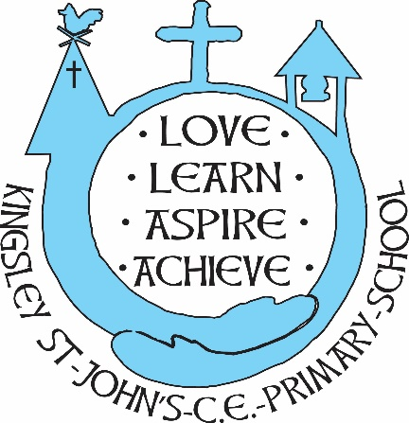
Kingsley St. John’s Art and Design Curriculum
Progression and Skills

Our Kingsley St. Johns Art and Design curriculum, progression and skills have been developed to achieve the aims of the National Curriculum giving our children the best possible experience, skills and understanding of the subject whilst enriching and encompassing other areas of our school curriculum.

References
The National Curriculum for Art and Design, 2014

NSEAD’s parallel National Curriculum for Art and Design

Primary Art, Craft & Design. Knowledge and Skills Progression. Paul Carney, NSEAD registered Art & Design Education Consultant

The National Curriculum for Art and Design. Guidance: EYFS, Primary KS1-2. A Framework for Progression, Planning for Learning, Assessment, Recording and Reporting. The National Society for Education in Art and Design. June 2014
AccessArt Progression Plan for Primary Art 2020, Paula Briggs and Shiela Ceccarelli

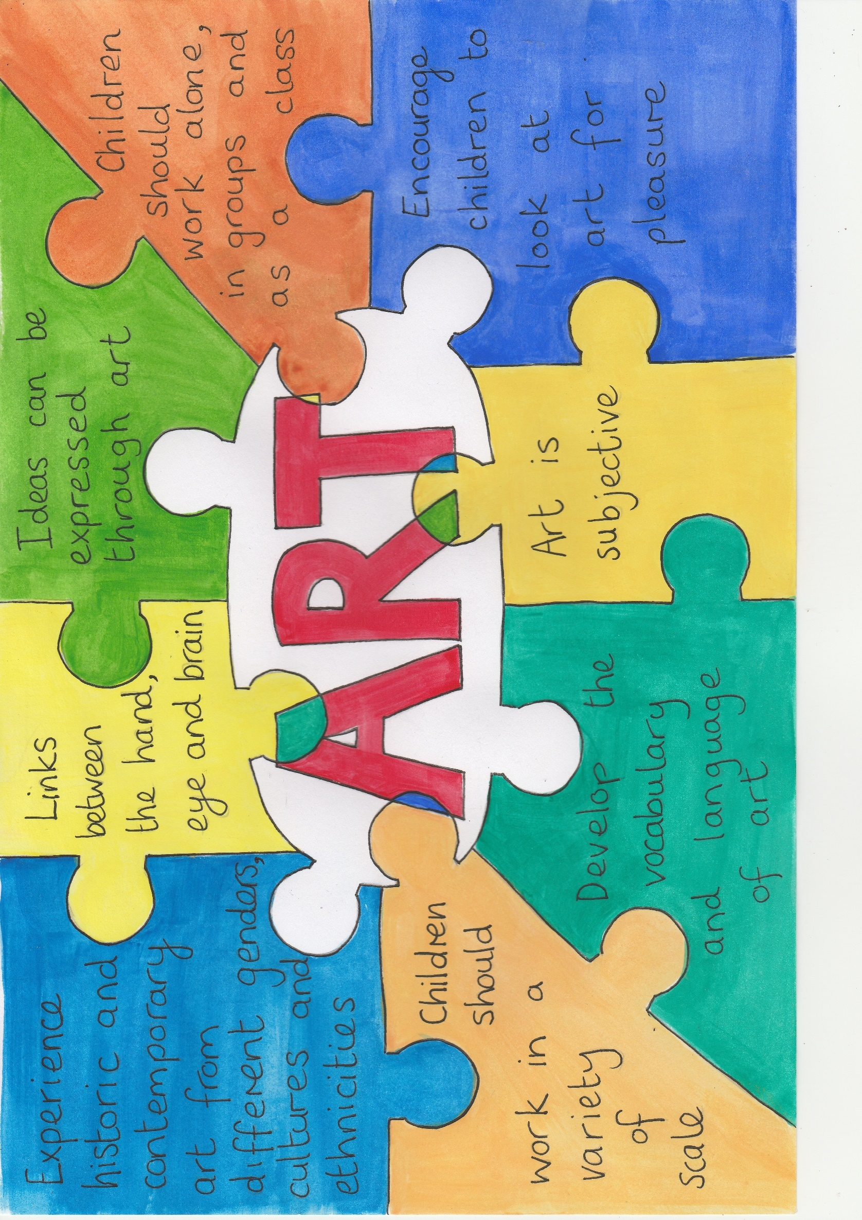
 | EYFS | Year 1 | Year 2 | Year 3 | Year 4 | Year 5 | Year 6
Knowledge and Understanding | Know that art, design and craft is made by artists using care and skill | Know that there are different forms of art and creative works made by artists, craftspeople, architects and designers | Know that there are different forms of art and creative works made by artists, craftspeople, architects and designers from all cultures, times and for different purposes | Know that there are different forms of art and creative works made by artists, craftspeople, architects and designers from all cultures, times and for different purposes | Know about and describe the key ideas, techniques and working practices of a variety of artists, craftspeople, architects and designers from all cultures, times and for different purposes. | Know about and describe the key ideas, techniques and working practices of a variety of artists, craftspeople, architects and designers from all cultures, times and for different purposes. | Understand the influence of different social, cultural and historical contexts in which artists work or worked.
 | Talk about works of art and what interests them about them | Study works of art including how and when they were made and what interests them about them and how they make them feel | Study works of art including how and when they were made, what interests them about them and describe the feelings and emotions conveyed by the work | Study works of art. How and when they were made and areas of interest. Describe the feelings and emotions conveyed by the work. Understand who made it, how and the background to the art. | Study works of art. How and when they were made and areas of interest. Describe the feelings and emotions conveyed by the work. Understand who made it, using which techniques and the background to the art. | Study and research works of art. Use the method of: Content, Process, Formal Elements, Mood and understand the background to the art.  Use studies to learn techniques and use them to produce original work | Study and research works of art. Use the method of: Content, Process, Formal Elements, Mood and understand the background to the art.  Use studies to learn techniques and use them to produce original work
 | Include artists of different genders and ethnicities, both historical and contemporary
 | Begin to learn the meaning of the Formal Elements  Orally describe their work and what they are doing  Know the names of tools | Learn the meaning of the Formal Elements and start use them in their own work describing how they are using them  Know the names of tools and techniques | Learn the meaning of the Formal Elements and start use them in their own work describing how they are using them  Know the names of tools and techniques | Know the meaning and further develop use of the formal elements. Recognise and describe their use in their own work and that of others  Know the names of tools and techniques | Know the meaning and further develop use of the formal elements. Recognise and describe their use in their own work and that of others  Know the names of tools and techniques | Develop confidence in using and describing the use of the formal elements to create more complex work  Know the names of tools and techniques | Develop confidence in using and describing the use of the formal elements to create more complex work  Know the names of tools and techniques

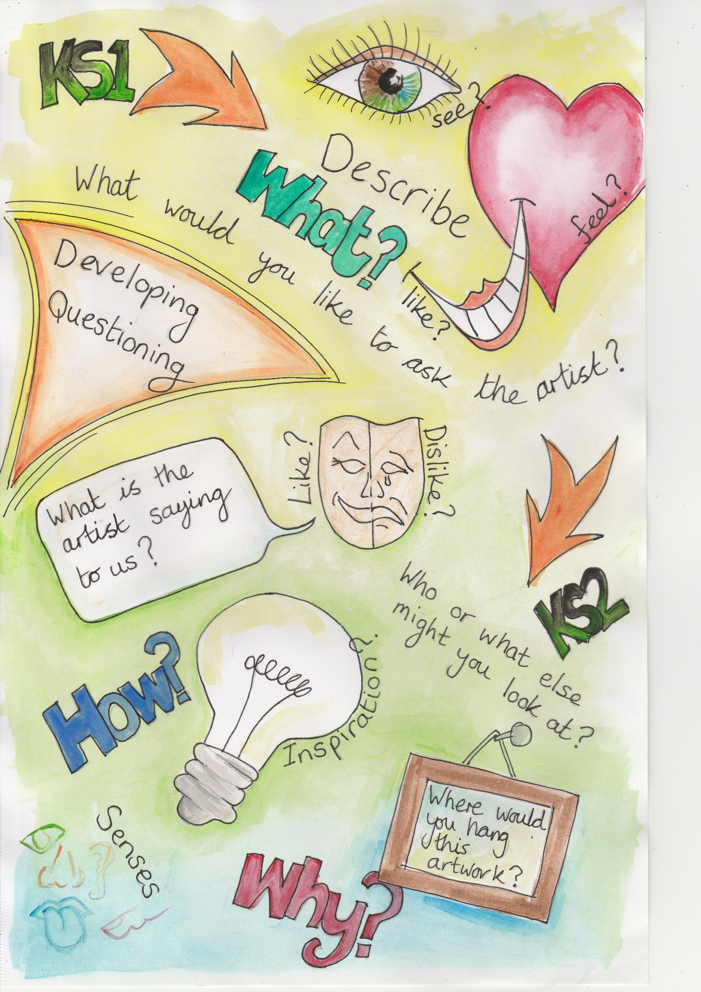
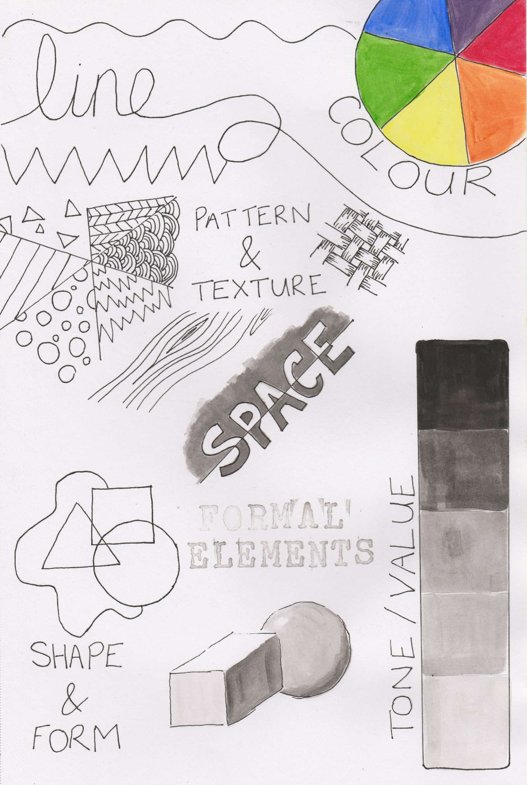

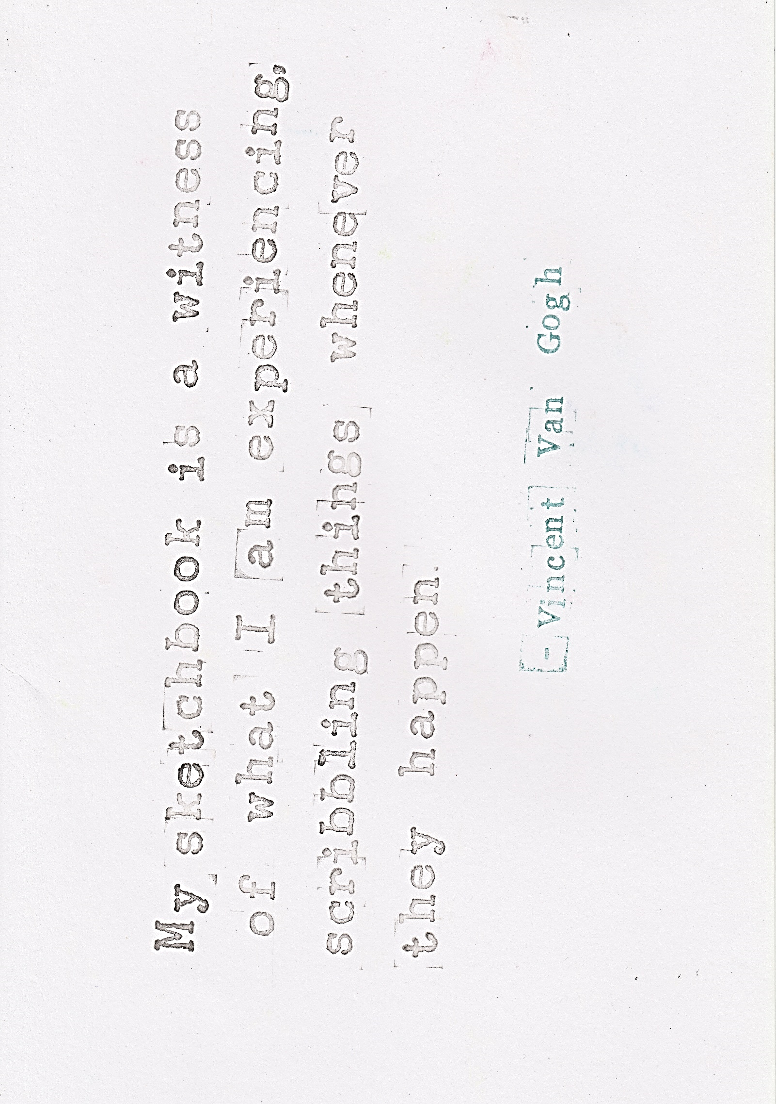
 | EYFS | Year 1 | Year 2 | Year 3 | Year 4 | Year 5 | Year 6
Exploring and Generating Ideas | Work purposefully responding to colours, shapes, materials etc.  Use opportunities for visiting, seeing, holding and hearing | Generate ideas through hands on exploration as well as thinking about existing knowledge  Use opportunities for visiting, seeing, holding and hearing  Study the work of artists and cultures | Generate ideas through hands on exploration as well as thinking about existing knowledge  Use opportunities for visiting, seeing, holding and hearing including found and man-made objects  Study the work of artists and cultures and use this to influence their work | Generate ideas through hands on exploration as well as thinking about existing knowledge  Use opportunities for visiting, seeing, holding and hearing including found and man-made objects  Study the work of artists and cultures and use this to influence their work  Explore art forms beyond the visual arts and how they relate to the visual arts  Explore the variety of source material available and understand the differences | Generate ideas through hands on exploration as well as thinking about existing knowledge  Use opportunities for visiting, seeing, holding and hearing including found and man-made objects  Study the work of artists and cultures and use this to influence their work  Explore art forms beyond the visual arts and how they relate to the visual arts  Explore the variety of source material available and understand the differences | Generate ideas through exploration, existing knowledge and opportunities that engage the senses  Use a variety of source material, gather and review information, references and resources including digital media and other art forms related to their ideas and intentions  Engage in open ended research in the process of initiating and developing own ideas  Look at work by artists, craftspeople, architects and designers, discuss their intention and reflect on their own response | Generate ideas through exploration, existing knowledge and opportunities that engage the senses  Use a variety of source material, gather and review information, references and resources including digital media and other art forms related to their ideas and intentions  Engage in open ended research in the process of initiating and developing own ideas  Look at work by artists, craftspeople, architects and designers, discuss their intention and reflect on their own response
Exploring and Generating Ideas | Learn how ideas change, grow and develop as work is produced. | Use sketchbooks to explore, develop and share ideas | Continued use of sketchbooks, exploring at own pace  Use sketchbooks to explore, develop and share ideas | Continued use of sketchbooks, exploring at own pace  Use sketchbooks to collect, test, explore, plan and shape ideas and record observations. | Continued use of sketchbooks, developing a sketchbook ‘habit’  Use sketchbooks to collect, test, explore, plan and shape ideas and to record observations, thoughts, feelings and discoveries | Continued use of sketchbooks, developing a sketchbook ‘habit’ using it in a variety of ways  Use sketchbooks and drawing to plan for outcomes using labelling for learning and record keeping  Use digital stills and video to ‘see’ and ‘collect’ creating a digital sketchbook  View a sketchbook as a place that raises questions which can be explored and answered outside the sketchbook | Continued use of sketchbooks, developing a sketchbook ‘habit’ using it in a variety of ways  Use sketchbooks and drawing to plan for outcomes using labelling for learning and record keeping  Use digital stills and video to ‘see’ and ‘collect’ creating a digital sketchbook  View a sketchbook as a place that raises questions which can be explored and answered outside the sketchbook
 | Create art from both imagination and other things  Create simple representations of people and other things | Create art using experiences, knowledge, preferences and imagination  Produce an individual, personal response to a theme or topic | Create art using experiences, knowledge, preferences and imagination  Produce an individual, personal response to a theme or topic | Create art using experiences, knowledge, preferences and imagination – try to reimagine what they know  Create art from things they have seen, nature, the environment, still life, photos  Produce an individual, personal response to a theme or topic | Create art using experiences, knowledge, preferences and imagination – try to reimagine what they know  Create art from things they have seen, nature, the environment, still life, photos  Produce an individual, personal response to a theme or topic | Create art from things they have seen, nature, the environment, still life, photos they have taken  Create art from aspirations for their future and the future of others. Fears, hopes and dreams for themselves and the world they live in  Produce an individual, personal response to a theme or topic | Create art from things they have seen, nature, the environment, still life, photos they have taken  Create art from aspirations for their future and the future of others. Fears, hopes and dreams for themselves and the world they live in.  Independently develop a range of ideas which show curiosity, imagination and originality in response to similar starting points
 | Explore a range of materials | Try different materials and activities and make choices about what to try next | Try different materials and activities and make choices about what to try next | Use growing knowledge of how materials and media act to develop ideas and make choices about what to try next  Be open about unexpected outcomes | Use growing knowledge of how materials and media act to develop ideas and make choices about what to try next  Explore how ideas translate through different media  Be open about unexpected outcomes | Use growing knowledge of how materials and media act to develop ideas  Develop increasing autonomy over choices and decision making  Take risks through experimentation and exploring ideas and see how they translate through different media | Use knowledge of how materials and media act to develop ideas and use them with increasing spontaneity and confidence  Continue to develop increasing autonomy over choices and decision making  Take risks through experimentation and exploring ideas and see how they translate through different media

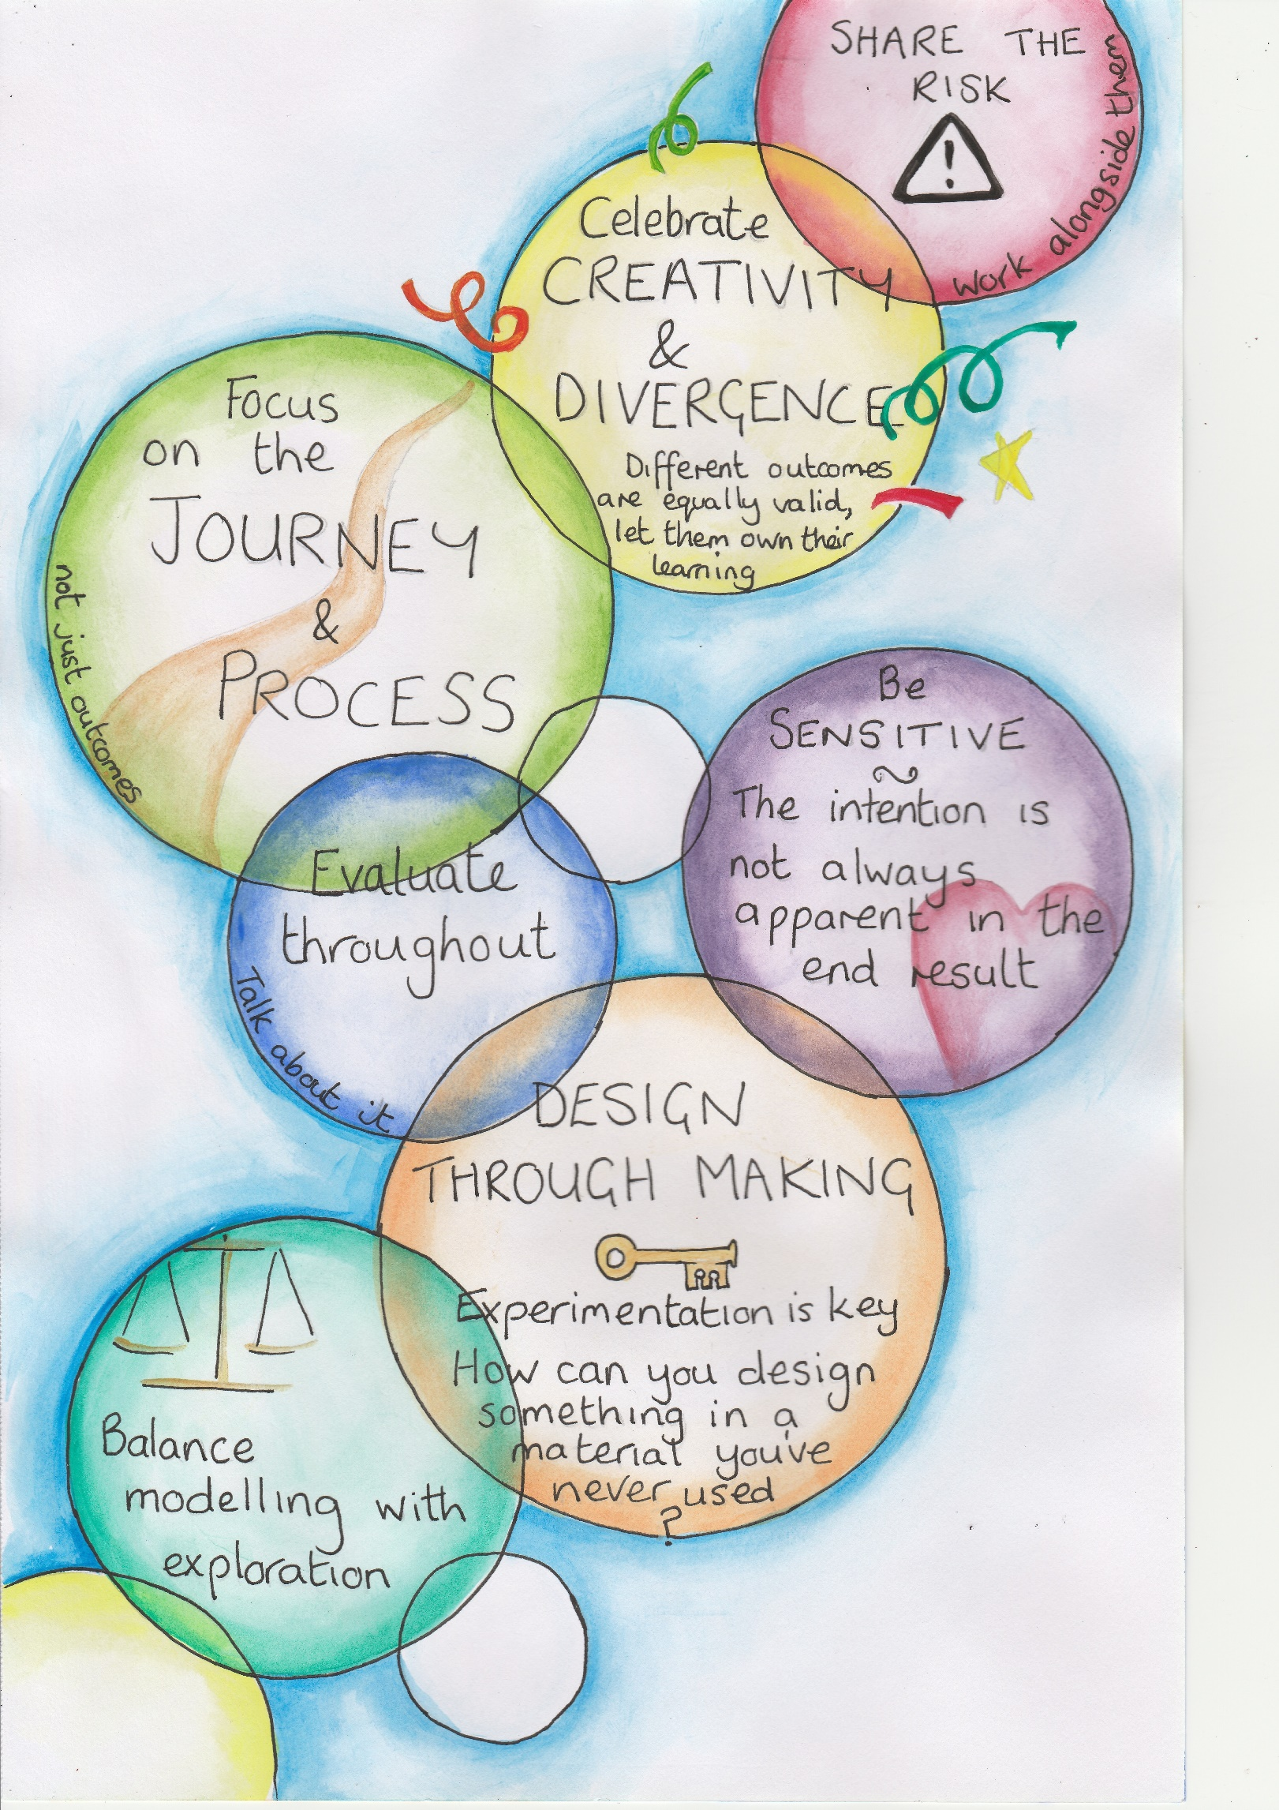

 | EYFS | Year 1 | Year 2 | Year 3 | Year 4 | Year 5 | Year 6
Making  (See expansion) | Work spontaneously and enjoy the act of making/creating  Begin to develop skill, control, confidence and concentration when using a range of materials and techniques | Are excited by the potential to make and create and understand that art allows discovery and invention  Continue to develop skill, control, confidence and concentration when using a range of materials and techniques  Explore a range of materials and processes and recognise different qualities  Use materials purposefully to achieve particular characteristics and qualities | Are excited by the potential to make and create and understand that art allows discovery and invention  Exercise greater care, skill and control when using a range of materials and techniques  Explore a range of materials and processes and recognise different qualities  Use materials purposefully to achieve particular characteristics and qualities  Deliberately choose particular techniques for a given purpose | Are excited by the potential to make and create and feel able to begin their own exploration  Continue to develop technique and exercise greater care, skill and control when using a range of materials  Work with greater detail and precision  Continue to explore a range of materials and processes and recognise different qualities  Explore combinations of materials  Use materials purposefully to achieve particular characteristics and qualities, deliberately choosing techniques for a given purpose  Design and make art for different purposes | Are excited by the potential to make and create and feel able to begin their own exploration  Continue to develop technique and exercise greater care, skill and control when using a range of materials  Work with greater detail and precision  and apply the technical skills they are learning to improve their work  Investigate the nature of a range of materials and processes systematically  Explore combinations of materials  Use materials purposefully to achieve particular characteristics and qualities, deliberately choosing techniques for a given purpose  Design and make art for different purposes | Are excited by the potential to make and create and feel able to begin their own exploration  Continue to develop and refine technique and exercise greater care, skill and control when using a range of materials  Use the technical skills they have learned to improve their work and make work that reflects their ideas and intentions  Confidently investigate the nature of new materials and processes and explore their potential  Increasingly use intuition to make creative choices regarding materials and processes to achieve the desired outcome in finished work  Design and make more complex art for different purposes | Are excited by the potential to make and create and feel able to begin their own exploration  Independently work to refine technical and craft skills improving their mastery of techniques and materials  Use the technical skills they have learned to improve their work and make work that reflects their ideas and intentions  Confidently investigate the nature of new materials and processes and explore their potential  Follow intuition to make creative choices regarding materials and processes to achieve the desired outcome in finished work  Design and make more complex art for different purposes

 | EYFS | Year 1 | Year 2 | Year 3 | Year 4 | Year 5 | Year 6
Drawing | Draw from imagination and observation  Draw things they like and learn to draw for pleasure and relaxation  Develop control and confidence drawing using a range of materials and scales  Learn to shade areas as neatly and carefully as they can | Draw from imagination and observation  Draw things they like, draw for pleasure and relaxation, to record ideas, thoughts, feelings and for narrative reasons  Continue to develop control and confidence drawing simple 2D shapes and using them to create more complex forms  Explore and experiment with a variety of drawing materials and scales  Explore mark-making and the use of line, shape and colour, introduce the concept of light and dark tones  Practice shading areas neatly and accurately  Become familiar with 2 or more drawing exercises, repeated over time to build skill | Explore a variety of drawing starting points, from observation of primary and secondary sources and drawing from memory and imagination  Draw things they like, draw to record ideas, thoughts, feelings and for narrative reasons  Show increased control and confidence drawing simple 2D shapes and using them to create more complex forms  Explore and experiment with a variety of drawing materials and scales  Develop mark-making skills, experiment with the use of line, shape, pattern and colour, light and dark tones using a variety of drawing materials  Experiment with layering different media  More effectively blend shading and begin to refine drawings  Continue to use drawing exercises to build skills. Children should lead those they are familiar with and new exercises can be introduced | Practice observational drawing from the figure, primary and secondary sources and drawing from memory and imagination  Draw for a variety of purposes: to record ideas, thoughts, feelings, experiences or describe events  Explore drawing 2D and 3D shape when drawing from observation or other sources  Continue to develop mark-making skills through the use of line, shape, pattern, texture, tone and colour learning to describe a range of surfaces, textures and forms  Continue to use a range of drawing materials and know the differences and similarities between them.  Make choices about which materials would best suit their purpose and continue to experiment with layering different media  Continue to use drawing exercises to build skills. Children should lead those they are familiar with and new exercises can be introduced | Continue to practice observational drawing and further explore experimental drawing  Draw for a variety of purposes: to record ideas, thoughts, feelings, experiences or describe events  Develop skill in drawing 2D and 3D shape when drawing from observation or other sources  Use their increasing mark-making skills and the use of line, shape, pattern, texture, tone and colour to describe a range of surfaces, textures and forms  Use growing knowledge of drawing materials and their properties to make reasoned choices about which materials would best suit their purpose  Continue to use drawing exercises to build skills and apply these skills to different media | Draw from observation and practice experimental drawing using a variety of source material  Draw for a variety of purposes including thinking, planning, designing and realising  Draw with increasing confidence and awareness of 2D and 3D form  Understand that we all draw differently and explore a range of drawing styles  Look at different artists styles and use those they like to influence their own style  Choose and experiment with their mark-making making skills for different purposes to achieve the desired outcome  Independently select appropriate media for expression and purpose.  Continue with key drawing exercises | Draw from observation and practice experimental drawing using a variety of source material  Draw for a variety of purposes including thinking, planning, designing and realising  Draw with increasing confidence, developing ability to skilfully control outcomes  Explore a wider range of drawing styles and understand how drawing is used in art  Further explore different artist’s styles and continue to develop their own style  Choose and experiment with their mark-making making skills for different purposes to achieve the desired outcome  Explore drawing and mark making on new surfaces and in different genres  Independently select appropriate media for expression and purpose.  Continue with key drawing exercises

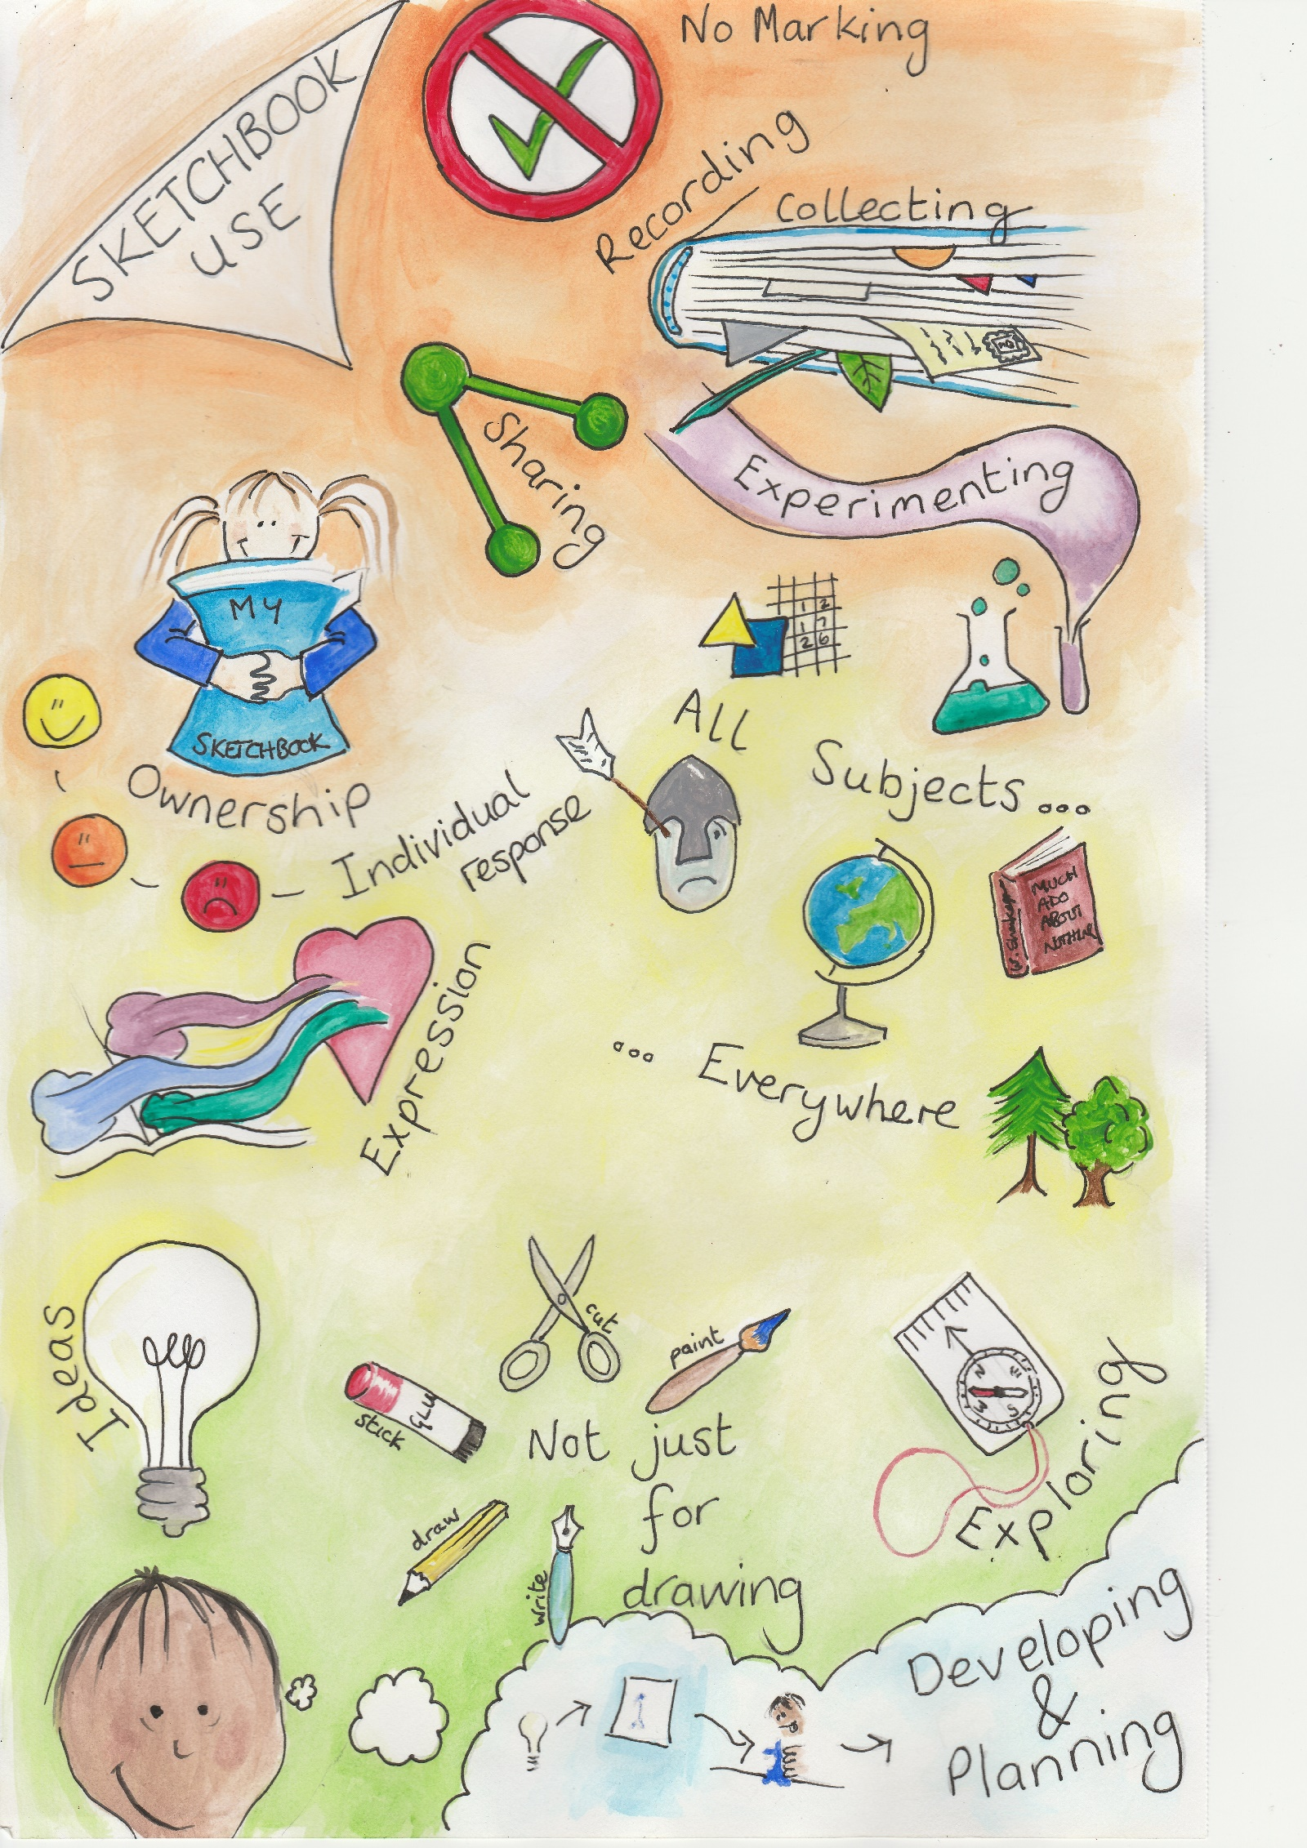
 | EYFS | Year 1 | Year 2 | Year 3 | Year 4 | Year 5 | Year 6
Sketchbooks |  | Introduce sketchbooks and use them for exploring and experimenting  Understand how a sketchbook might be used and for what activities  Begin to feel a sense of ownership of their sketchbook | Make or modify existing sketchbooks and explore how to make spaces and places, shapes textures etc. This will help to increase the sense of ownership  Understand how a sketchbook might be used and for what activities, collecting, recording etc.  Begin to develop a sketchbook habit | Make or modify existing sketchbooks and explore how to make spaces and places, shapes textures etc. This will help to increase the sense of ownership  Work at own pace and follow own ideas and exploration  Practice and develop sketchbook use, expanding the way it is used and the activities it can be used for: Exploring materials and colour, testing and developing ideas, collecting, recording, writing notes, looking back etc. | Continue to make or modify existing sketchbooks and explore how to make spaces and places, shapes textures etc. Feel an increasing sense of ownership  Work at own pace and follow own ideas and exploration  Practice and develop sketchbook use, expanding the way it is used and the activities it can be used for: Exploring materials and colour, testing and developing ideas, collecting, recording, writing notes, looking back, thinking around the subject, reflecting and making links. | Make or modify existing sketchbooks according to their own needs, ideas and explorations, feeling an increasing sense of ownership  Work at own pace and follow own ideas and exploration building the links between the sketchbook, the journey and the outcome of their work  Practice and develop sketchbook use, expanding the way it is used and the activities it can be used for: Exploring materials and colour, testing and developing ideas, collecting, recording, writing notes, looking back, thinking around the subject, reflecting and making links.  Increasingly see the sketchbook as a place that raises questions which can be answered outside the sketchbook | Make or modify existing sketchbooks according to their own needs, ideas and explorations, feeling an increasing sense of ownership  Work at own pace and follow own ideas and exploration building the links between the sketchbook, the journey and the outcome of their work  Practice and develop sketchbook use, expanding the way it is used and the activities it can be used for: Exploring materials and colour, testing and developing ideas, collecting, recording, writing notes, looking back, thinking around the subject, reflecting and making links.  Increasingly see the sketchbook as a place that raises questions which can be answered outside the sketchbook
Painting | Learn how to hold and control a paintbrush  Learn how to blend colours on a palette and explore colour mixing with primary colours  Learn how to make colours darker or lighter  Experiment with mark making using a variety of tools | Develop control painting shapes, lines and edges neatly  Learn how to blend colours on a palette and on paper. Explore colour mixing, recognise primary colours and create secondary colours  Use colour imaginatively and understand that it can be used to depict thoughts and feelings  Develop skills in making colours darker or lighter and how this affects form  Explore a variety of paints and their properties painting on a variety of surfaces  Transfer skills learned in drawing and use them in painting continuing to experiment with mark making using a variety of tools  Discover the interplay between materials, e.g. wax and watercolour | Continue to develop control painting shapes, lines and edges neatly  Continue to develop colour mixing skills creating finer variations of secondary colours  Use colour imaginatively and understand that it can be used to depict thoughts and feelings  Transfer colour mixing knowledge to other media  Expand knowledge of different paints and their properties painting on a variety of surfaces including 3D  Develop skills in making colours darker or lighter and how this affects form learning about depth (lighter closer, darker further away)  Transfer skills learned in drawing and use them in painting continuing to experiment with mark making using a variety of tools  Discover the interplay between materials, e.g. wax and watercolour | Pupils work with increased control, precision and detail  Develop colour mixing skills to secondary and tertiary colours.  Experiment with colour, texture line and shape with imagination and to express ideas, thoughts and feelings  Transfer colour mixing knowledge to other media and consider colour as decoration  Learn to create depth through varying tone and colour and understand how it adds interest to paintings  Know about different paints and their properties painting on a variety of surfaces including 3D  Identify a variety of tools and brushes and their uses  Explore traditional, contemporary and unorthodox methods of painting using a variety of materials and tools and learn how to paint with expression  Build on previously learned skills in colour, drawing and mark making and how combinations can affect outcome  Continue to explore the interplay between materials, e.g. wax and watercolour | Pupils work with increased control, precision and detail  Develop colour mixing skills to secondary and tertiary colours.  Experiment with colour, texture line shape and composition with imagination and to express ideas, thoughts and feelings  Transfer colour mixing knowledge to other media and consider colour as decoration  Learn to create depth through varying tone and colour and understand how it adds interest to paintings  Know about different paints and their properties and when to use them painting on a variety of surfaces.  Identify a variety of tools and brushes and their uses  Explore traditional, contemporary and unorthodox methods of painting using a variety of materials and tools and learn how to paint with expression  Build on previously learned skills in colour, drawing and mark making and how combinations can affect outcome  Continue to explore the interplay between materials, e.g. wax and watercolour | Pupils can work in different ways with control, precision and can also paint in a more creative style  Can mix secondary and tertiary colours controlling them to use for their own purposes  Knows about colour relationships such as complimentary and harmonious colours  Can use tone, line, texture and colour to express mood and feeling  More confidently create 3D form and depth through varying tone and colour  Know about and name different paints, surfaces, tools and brushes and their properties and use them appropriately  Continues to explore traditional, contemporary and unorthodox methods of painting using a variety of materials and tools painting with expression  Uses previously learned skills in colour, drawing and mark making to achieve desired outcome  Uses the interplay between materials to express ideas and create the desired effects | Pupils can work in different ways with control, precision and detail but can also paint loosely and instinctively  Confidently mix secondary and tertiary colours controlling them to use for their own purposes  Understand colour relationships such as complimentary and harmonious colours  Can use tone, line, texture and colour to express mood and feeling  More confidently create 3D form and depth through varying tone and colour  Know about and name different paints, surfaces, tools and brushes and their properties and use them appropriately  Continues to explore traditional, contemporary and unorthodox methods of painting using a variety of materials and tools painting with expression  Uses previously learned skills in colour, drawing and mark making to achieve desired outcome  Uses the interplay between materials to express ideas and create the desired effects
Craft & Collage | Work with a variety of materials, cutting gluing and forming  Decorate surfaces and textiles with beads, sequins etc  Select and cut colours, shapes, textures and images from a range of sources to suit ideas and purposes | Work with a variety of materials, cutting gluing, sewing and forming  Decorate surfaces and textiles with increasing detail and complexity  Select and cut colours, shapes, textures and images from a range of sources to suit ideas and purposes | Work with a variety of materials, cutting gluing, sewing and forming  Decorate surfaces and textiles with increasing detail and complexity  Select and cut colours, shapes, textures and images from a range of sources to suit ideas and purposes  Make links to drawing and mark making etc. | Explore a wider range of crafts linking to topics and themes  Build confidence in making choices and work with increasing detail and complexity  Explore the different available source materials and select from a range to suit ideas and purposes  Make links to drawing and mark making etc. and use in multimedia projects | Explore a wider range of crafts linking to topics and themes  Build confidence in designing and planning work and making choices, working with increasing detail and complexity  Explore the different available source materials and select from a range to suit ideas and purposes  Make links to drawing and mark making etc. and use in multimedia projects | Gain experience using collage as an art form and continue to explore a wider range of crafts linking to topics and themes  Continue to build confidence in designing and planning work and making choices, working with increasing detail and complexity  Research different available source materials and select from a range to suit ideas and purposes, taking into consideration colour, texture etc.  Make links to drawing and mark making etc. and use in multimedia projects | Gain experience using collage as an art form and continue to explore a wider range of crafts linking to topics and themes  Design and plan work making reasoned choices, working with increasing detail and complexity  Research different available source materials and select from a range to suit ideas and purposes, taking into consideration colour, texture etc.  Make links to drawing and mark making etc. and use in multimedia projects
Printmaking | Make simple prints with their hands and soft materials they have cut shaped or moulded | Make simple prints using materials such as card, string, textured materials, clay etc. and to explore pattern.  Learn about different types of printing: Mono printing, block printing, relief printing etc.  Create rubbings | Pupils make prints and use printing to create artwork linked to wider topics and themes and to explore pattern.  Learn about different types of printing: Mono printing, block printing, relief printing etc.  Explore mono printing in various media and relate to drawing and colour | Pupils make prints and use printing to create artwork linked to wider topics and themes and to explore more complex patterns.  Use different types of printing and explore printing on different surfaces  Introduce layering  Explore mono printing in various media and relate to drawing and colour | Pupils make prints and use printing to create artwork linked to wider topics and themes and to explore more complex patterns.  Use different types of printing and explore printing on different surfaces  Use layering  Explore combining print with other artforms to create mixed media work | Pupils develop more complex printing to create artwork that might be singular images or patterns  Know and are able to describe different print methods  Use more complex printing blocks with precision  Use layering and have confidence printing on different surfaces  Make choices regarding methods, colours and inks and modify work | Pupils create more complex prints to create artwork that speaks of their ideas and intentions  Know and are able to describe different print methods  Use more complex printing blocks with precision  Use layering and have confidence printing on different surfaces  Make choices regarding methods, colours and inks and modify work
3D | 3D work is made by cutting, forming and joining similar 3D shapes such as packaging and boxes  Create simple shapes and forms from pliable materials such as clay, foam or wire | 3D work is made by cutting, tearing, forming and joining a range of materials, 2 and 3D including found and man-made to make things they have designed, seen or imagined | 3D work is made by cutting, tearing, forming and joining a range of materials, 2 and 3D including found and man-made to make things they have designed, seen or imagined  Explore how 2D can become 3D linking to other areas  Make simple plans for making including ordering tasks and asking for advice  Can begin to modify and correct their work | Plan and design 3D work made by cutting, tearing, forming and joining a range of materials, 2 and 3D including found and man-made to make things they have designed, seen or imagined  Continue to explore how 2D can become 3D linking to other areas  Explore combining materials and links to other areas  Can modify and correct their work and understand how to finish and present it to a good standard | Plan and design 3D work and are more confident in making by cutting, tearing, forming and joining a range of materials, 2 and 3D including found and man-made to make things they have designed, seen or imagined  Continue to explore how 2D can become 3D linking to other areas  Can modify and correct their work showing perseverance when work becomes challenging. They understand how to finish and present work to a good standard | Plan and design more complex 3D work and work confidently and safely with a range of materials and tools, including found and man-made to make things they have designed, seen or imagined for different purposes  Can modify and correct their work showing perseverance when work becomes challenging. They understand how to finish and present work to a good standard | Plan and design more complex 3D work and work confidently and safely with a range of materials and tools, including found and man-made to make things they have designed, seen or imagined for different purposes  Can modify and correct their work showing perseverance when work becomes challenging. They understand how to finish and present work to a good standard
Digital Media | Take photos with digital cameras/devices learning to focus and position what they see.  Apply filters to results | Take photos with digital cameras/devices taking care to frame the shot for their purpose  Use simple software to edit and manipulate photos | Take photos and video with digital cameras/devices taking care to frame the shot for their purpose  Use simple software to edit and manipulate photos, use painting software to edit photos to create more complex images  Use digital media to make records of their work, as a stimulus and to incorporate into other media | Use digital media to make art through drawing and painting programmes, vector drawing and photo manipulation  Use simple software to edit and manipulate photos, use painting software to edit photos to create more complex images  Use digital media to make records of their work, as a stimulus and to incorporate into other media  Use digital media to make animations from drawings | Use digital media to make art through drawing and painting programmes, vector drawing and photo manipulation  Use simple software to edit and manipulate photos, use painting software to edit photos to create more complex images  Use digital media to make records of their work, as a stimulus and to incorporate into other media  Use digital media to make animations from drawings | Use digital media to make more complex art through drawing and painting programmes, vector drawing and photo manipulation  Use software to edit and manipulate photos, use painting software to edit photos to create more complex images  Use digital media to make records of and present their work in different ways, as a stimulus and to incorporate into other media  Use digital media to make animations from drawings | Use digital media to make more complex art through drawing and painting programmes, vector drawing and photo manipulation  Use software to edit and manipulate photos, use painting software to edit photos to create more complex images  Use digital media to make records of and present their work in different ways, as a stimulus and to incorporate into other media  Use digital media to make animations from drawings
Design | Make something they have imagined or invented | Design and make something they have imagined or invented, for example realising a drawing in 3D | Design and make something they have imagined or invented using more complex forms  Invent for problem solving or create imaginary worlds | Design and make art for different purposes  Explore design through making and manipulating materials  Invent for problem solving or create imaginary worlds | Design and make art for different purposes  Develop design through making and manipulating materials  Invent for problem solving or create imaginary worlds | Have opportunities to design and make art for different purposes.  Explore materials and how to manipulate them  Explore links to all areas of art and other areas of the curriculum  Solve design problems, invent, create or imagine | Have increasingly challenging opportunities to make art for different purposes.  Continue to explore materials, transforming materials and work in mixed media  Explore links to all areas of art and other areas of the curriculum  Solve design problems, invent, create or imagine

 | EYFS | Year 1 | Year 2 | Year 3 | Year 4 | Year 5 | Year 6
Evaluating | Orally describe their own work and ideas | Develop skills in orally describing their thoughts, ideas and intentions about their work  Share work with others and listen to the opinions of others on that work  Express and share their own preferences and opinions  Begin to use technical vocabulary  Discuss the process used in their work | Continue to develop skills in describing their thoughts, ideas, intentions and outcome of their work and how it could be improved  Share work with others and listen to the opinions of others on that work  Express and share their own preferences and opinions giving reasons  Increased use of technical vocabulary  Understand the value of evaluating during as well as at the end of a piece of work and how this affects process  Offer critical advice to others, also offer praise and build confidence in others | Continue to develop skills in orally describing their work, the outcome and how it could be improved  Take time to reflect on their work and share it, and their thoughts on it. Listen to the opinions of others on that work  Continue to build and develop confidence in expressing and sharing opinions on their own and others work, giving reasons for them  Increased use of technical vocabulary  Understand the value of evaluating during as well as at the end of a piece of work and how this affects process  Offer critical advice and make suggestions to others using experiences or things they have seen. Also offer praise and build confidence in others | Orally describe their work, the outcome and how it could be improved with increasing confidence  Regularly analyse and reflect upon their progress and work.  Share it, and their thoughts on it, taking into account what they hoped to achieve. Listen to the opinions of others on that work  Continue to build and develop confidence in expressing and sharing opinions on their own and others work, giving reasons for them  Increased use of technical vocabulary  Offer critical advice and make suggestions to others using experiences or things they have seen. Also offer praise and build confidence in others | Orally describe their work, the outcome and how it could be improved with increasing confidence  Regularly analyse and reflect upon their progress and work.  Share it, and their thoughts on it, taking into account what they hoped to achieve. Listen to the opinions of others on that work  Continue to build and develop confidence in expressing and sharing opinions on their own and others work, giving reasons for them  Increased use of technical vocabulary  Offer critical advice and make suggestions to others using experiences or things they have seen. Also offer praise and build confidence in others  Accept criticism from others | Describe their work, the outcome and how it could be improved  Regularly analyse and reflect upon their progress and work.  Share it, and their thoughts on it, taking into account what they hoped to achieve. Listen to the opinions of others on that work  Continue to build and develop confidence in discussing, expressing and sharing opinions on their own and others work, giving reasons for them  Use of wide-ranging technical vocabulary  Offer critical advice and make suggestions to others using experiences or things they have seen. Also offer praise and build confidence in others  Accept criticism from others
 | Recognise and describe key features of their own and others work  Compare their art to famous works of art recognising what is the same and what is different | Recognise and describe key features of their own and others work  Compare their art to famous works of art recognising what is the same and what is different | Recognise and describe key features of their own and others work  Compare their art to famous works of art and the art of their peers recognising similarities and differences | Recognise and describe key features of their own and others work with increasing confidence and use of the language of art  Compare their art to famous works of art and the art of their peers recognising similarities and differences  Explore why the work was made as well as how | Recognise and describe key features of their own and others work with increasing confidence and use of the language of art  Compare their art to famous works of art and the art of their peers recognising similarities and differences. Use these comparisons to identify ways to improve  Share how other artists/artwork has inspired them  Explore why the work was made as well as how  Have an increasing awareness of purposes and reasons for art | Recognise and describe key features of their own and others work with increasing confidence and use of the language of art  Compare their art to famous works of art and the art of their peers recognising similarities and differences. Use these comparisons to identify ways to improve  Share how other artists/artwork has inspired them and how their work fits into a larger context  Explore why the work was made as well as how  Have an increasing awareness of purposes and reasons for art | Recognise and describe key features of their own and others work with increasing confidence and use of the language of art  Provide a reasoned evaluation of their own and professional’s work taking into account starting points, intentions and the context of the work. Use comparisons to identify ways to improve  Share how other artists/artwork has inspired them and how their work fits into a larger context  Explore why the work was made as well as how  Have an increasing awareness of purposes and reasons for art, its role in society and potential career opportunities
 | Make creative decisions about their work | Make creative decisions about their work, making choices about outcomes | Make creative decisions about their work, making choices about outcomes  Photograph their work to create a folio capturing progression and providing an opportunity for discussion | Make creative decisions about their work, making choices about outcomes.  Discuss problems, how they were solved and what might be tried next time  Photograph their work to create a folio capturing progression and providing an opportunity for discussion including the presentation of work | Make creative decisions about their work, making choices about outcomes.  Discuss problems, how they were solved and what might be tried next time  Photograph their work to create a folio capturing progression and providing an opportunity for discussion including the presentation of work | Make creative decisions about their work, making choices about outcomes.  Discuss problems, how they were solved and what might be tried next time  Photograph their work to create a folio capturing progression and providing an opportunity for discussion including the presentation of work  Present work in retrospect for example, to their class, parents or an assembly | Make creative decisions about their work, making choices about outcomes.  Discuss problems, how they were solved and what might be tried next time  Photograph their work to create a folio capturing progression and providing an opportunity for discussion including the presentation of work  Use digital media as a way to ‘re-see’ work  Present work in retrospect for example, to their class, parents or an assembly

