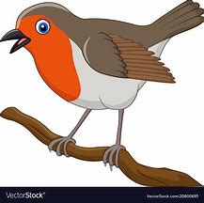 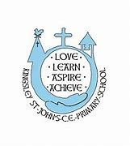

**Robin’s weekly update**

8th October 2021



Harvest

The Robins who attended their first whole school church service on Thursday, sang beautifully and were so interested in what Reverend Ron told us about Harvest.

Well done.

[cowell@kingsleystjohns.co.uk](mailto:cowell@kingsleystjohns.co.uk)

[raynor@kinsleystjohns.co.uk](mailto:raynor@kinsleystjohns.co.uk)

This week we are adding ‘Wind the Bobbin Up and ‘Five Currant Buns’ to our list of rhymes and songs.

When out and about maybe play a game of I Spy to help your child hear initial sounds in words.

We are about to start our new mini topic of Autumn.

If you are out and about with your child and you see anything which interests your child (helicopters or spinners, conkers, an unusually coloured leaf) either send us a photo or better still, send it into school so we can explore it.

**Maths language.**

We are continuing to look at simple patterns.

We are also using the words full, empty, half full, over flowing.