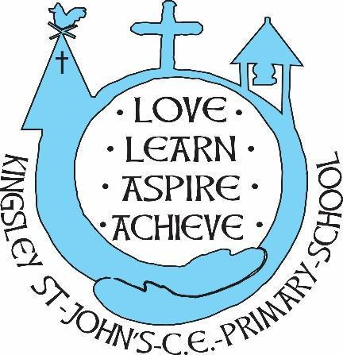
Kingsley St. John’s RE Curriculum
We believe in God as the great creator of all things - earth, day and night, seas and oceans, animals and plants and mankind, in his own image. We believe that we all have that same seed of creativity within us. At KSJ we nurture each and every seed. Regardless of our beliefs, background or vulnerability, our children are given all they need to grow, flourish and be the best that they can be.
Intent
At Kingsley St John’s, Religious Education contributes dynamically to children’s learning by provoking challenging questions about meaning and purpose in life, beliefs about God, ultimate reality, issues of right and wrong and what it means to be human. In RE they learn about and from religions and worldviews in local, national and global contexts, to discover, explore and consider different answers to these questions. They learn to weigh up the value of wisdom from different sources, to develop and express their insights in response, and to agree or disagree respectfully. We aim to provide a balance in the disciplines of theology, philosophy and human/social sciences. Theology encourages the children to explore beliefs, how they began and how they have changed and their application in different contexts. In philosophy the children are challenged to think about morality and ethics, encouraging reasoning and consideration of good and evil. Human/social sciences explore the diverse ways in which beliefs are practised and how they impact individuals, communities, and society.
Teaching therefore should equip pupils with systematic knowledge and understanding of a range of religions and worldviews, enabling them to develop their ideas, values and identities. It should develop in pupils an aptitude for dialogue so that they can participate positively in our society with its diverse religions and worldviews. Pupils should gain and deploy the skills needed to understand, interpret and evaluate texts, sources of wisdom and authority and other evidence.
Pupils learn to articulate clearly and coherently their personal beliefs, ideas, values and experiences while respecting the right of others to differ.

Being a KSJ Theologian:
- Know about and understand a range of religions and non-religious worldviews, so that they can:
• describe, explain and analyse beliefs and practices, recognising the diversity which exists within and between communities and amongst individuals;
• identify, investigate and respond to questions posed, and responses offered by some of the sources of wisdom* found in religions and and non-religious worldviews;
• appreciate and appraise the nature, significance and impact of different ways of life and ways of expressing meaning.
- Express ideas and insights about the nature, significance and impact of religions and worldviews, so that they can:
• explain reasonably their ideas about how beliefs, practices and forms of expression influence individuals and communities;
• express with increasing discernment their personal reflections and critical responses to questions and teachings about identity, diversity, meaning and value, including ethical issues;
• appreciate and appraise varied dimensions of religious and non-religious worldviews.
- Gain and deploy the skills needed to engage seriously with religions and worldviews, so that they can:
• find out about and investigate key concepts and questions of belonging, meaning, purpose and truth, responding creatively;
• enquire into what enables different individuals and communities to live together respectfully for the wellbeing of all;
• articulate beliefs, values and commitments clearly in order to explain why they may be important in their own and other people’s lives.
Implementation
- RE is taught using a 2-year rolling programme, based upon and adhering to the Diocese of Chester Syllabus.
- The syllabus is enquiry based with an exploration of Christianity and World Faiths.
- It provokes challenging questions about meaning and purpose, truth and values, identity and belonging.
- RE is a balance of three essential disciples of quality RE - Theology, Philosophy and Human Social Science.
- RE lessons should offer a structured and safe space during curriculum time for reflection, discussion, dialogue and debate.
- Lessons should also allow for timely and sensitive responses to be made to unforeseen events of a religious, moral or philosophical nature, whether local, national or global.
- Pupils will explore questions and answers raised in relation to the lived reality and impact of religion and world views on people’s lives.
Impact
- The practical approach at Kingsley St John’s results in a fun, engaging, high-quality RE education that provides children with the foundations and knowledge for understanding the world, Christianity and other religions.
- Through various workshops, trips and interactions with experts and local charities, children have the understanding that RE changes and nurtures lives and that it is important to the world’s social, moral, spiritual and cultural development.
- Children at KSJ overwhelmingly enjoy RE and this results in motivated learners with strong outcomes and attainment in RE.
- There is clear progression in knowledge, skills and understanding within RE.
- Measure curriculum success through scrutiny of work, learning walks, discussions, QA forms and pupil voice.
- Assess knowledge and understanding regularly.
- High standards of teaching and learning in RE.

