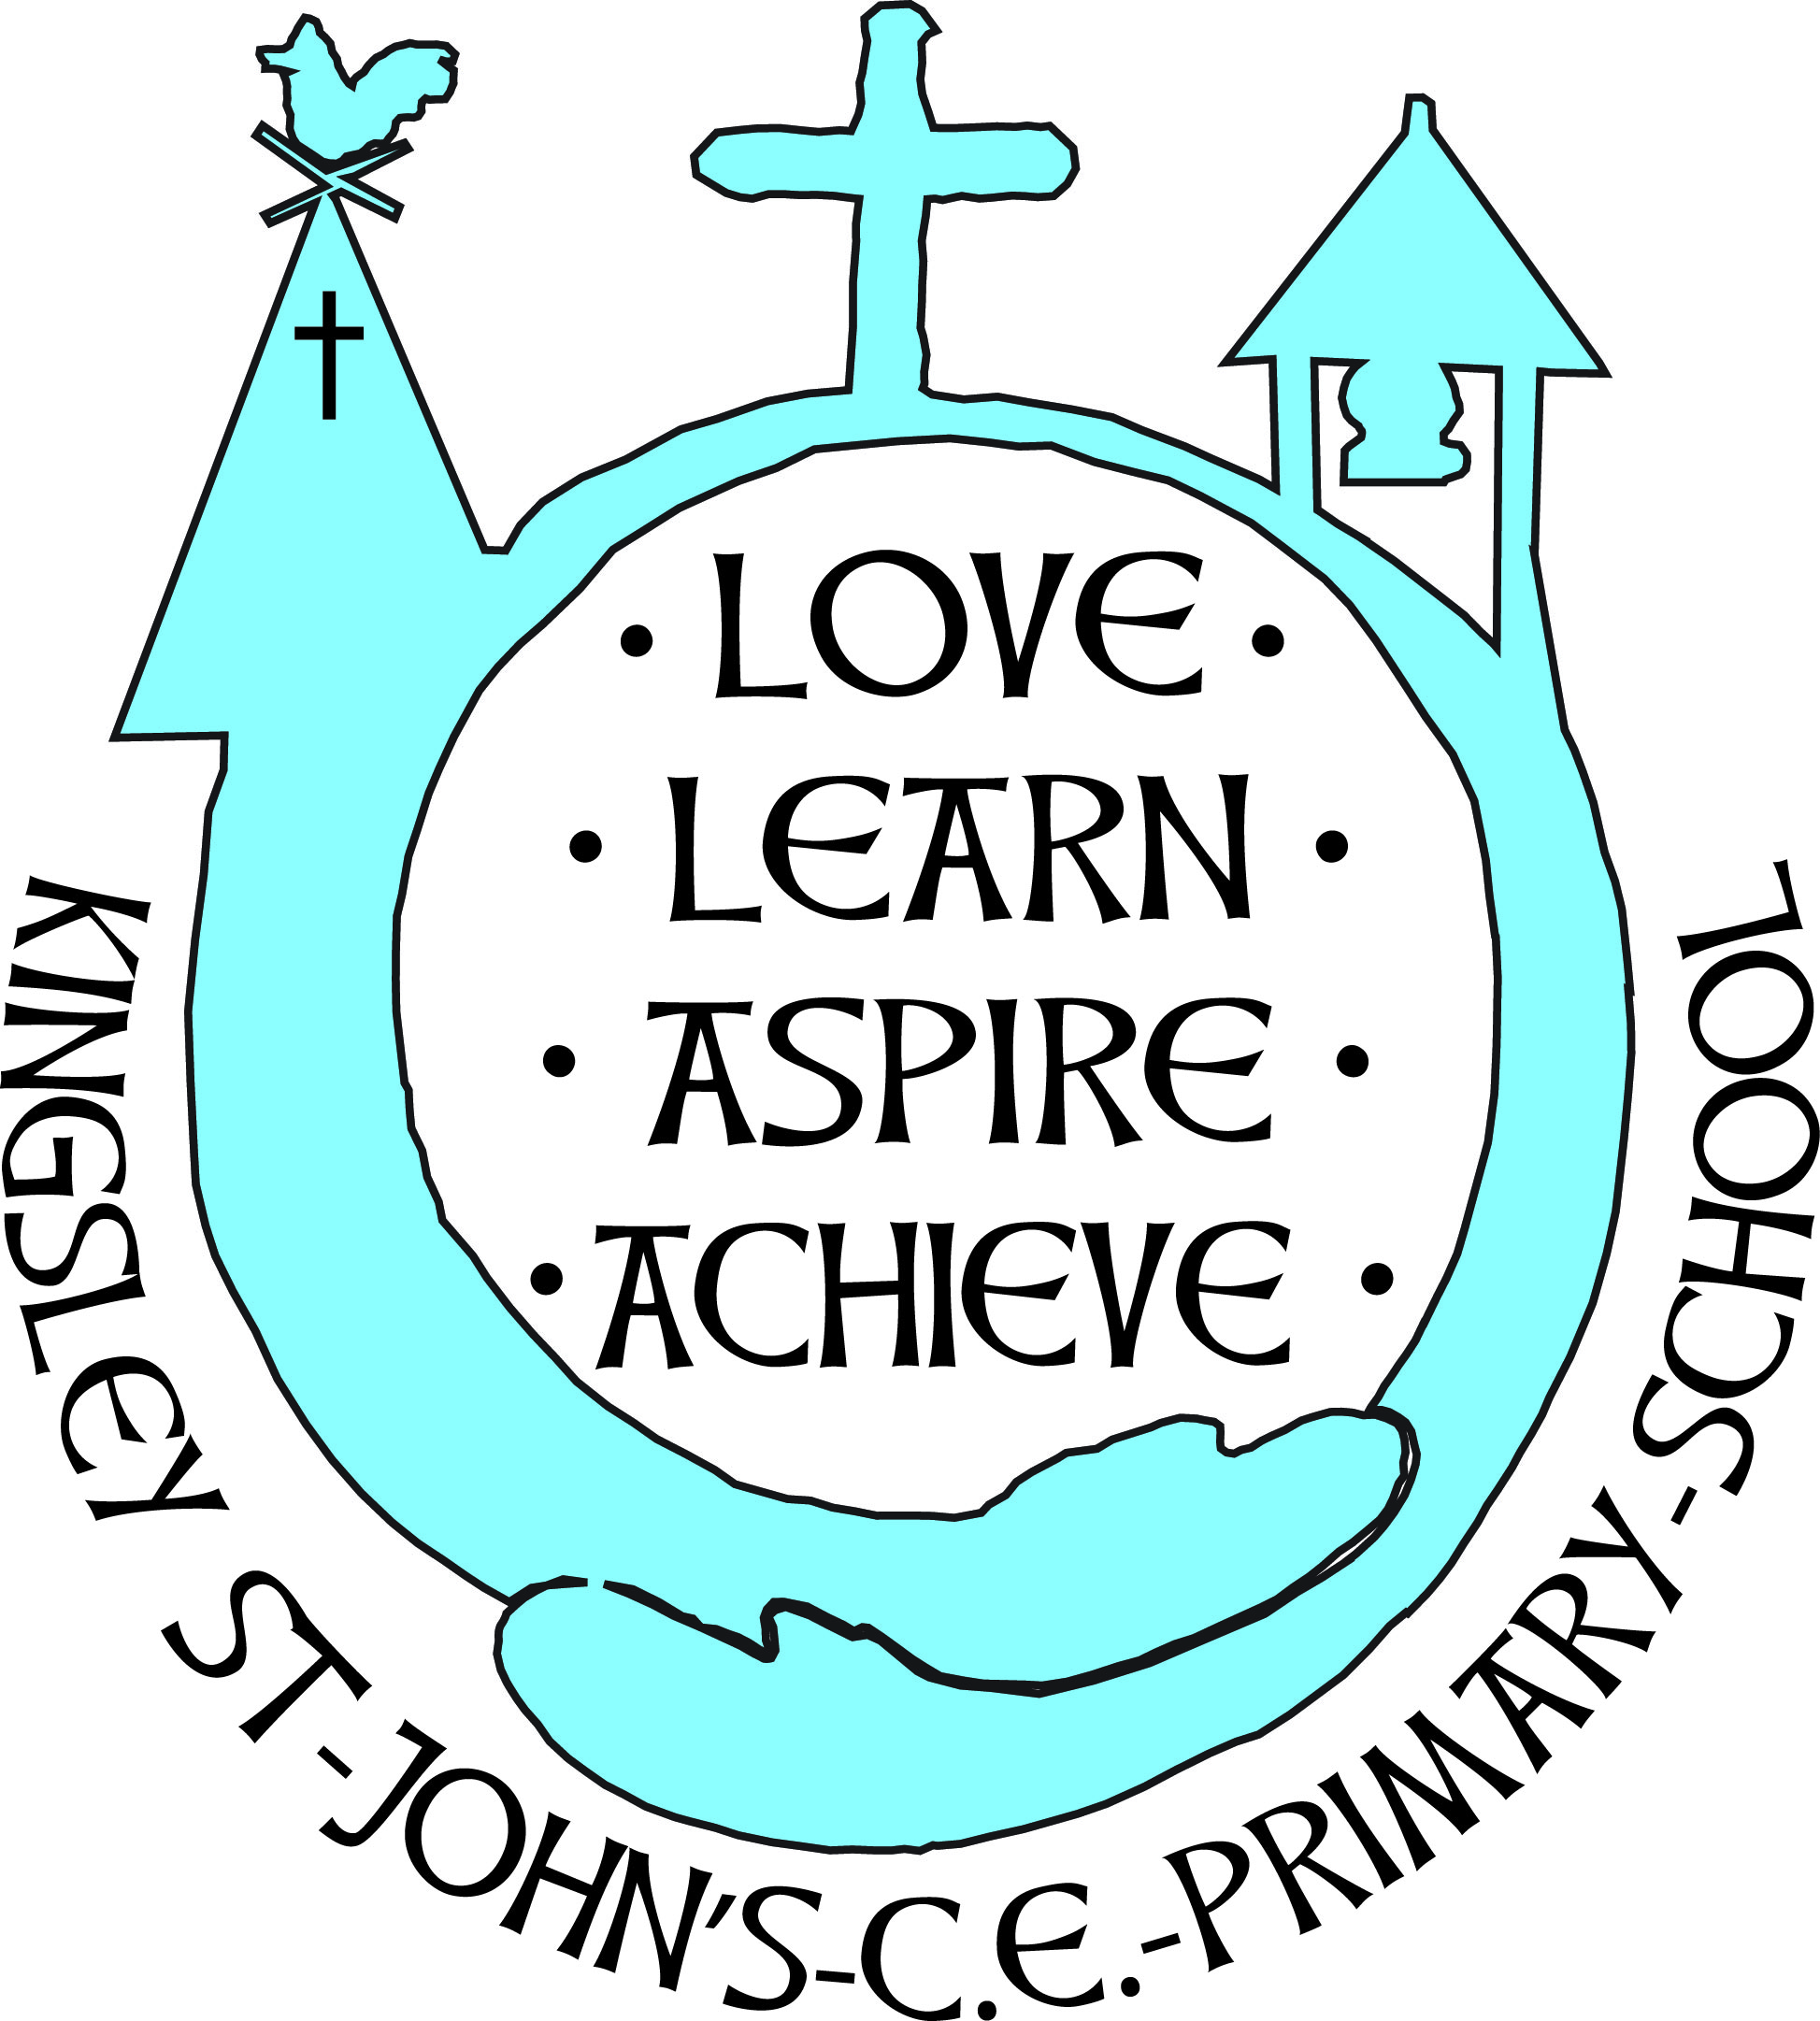 |  | Hollow Lane  Kingsley  Frodsham  Cheshire  WA6 8EF  Tel: (01928) 788536  Fax: (01928) 787600
Headteacher: Mrs R Jones | Email:  Email:  Website: | head@kingsley-st-johns.cheshire.sch.uk  kingsleystjohnsadmin@cheshirewestandchester.gov.uk  www.kingsley-st-johns.cheshire.sch.uk

1st February 2017
Dear Parents/Carers

Children’s Mental Health Week will take place from the 6th – 12th February 2017.
In 2017, the aim of our week is to encourage everyone — adults and children alike — to spread a little kindness.
We’ve all known someone going through a tough time, and it can be hard to know what to do to help, especially where children are involved. It may sound simple but in these moments, small acts of kindness can make all the difference.
Plus did you know studies show that being kind can make you happier and less stressed?
In school we will create a ‘gratitude jar.’ The children will be encouraged to write down anything they are grateful for, fold it up and place it into the jar. This will be located in the entrance by the school office.
The British Academy of Film and Television Arts (BAFTA) and Place2Be have partnered on a series of schools events – the ‘BAFTA Kids Roadshow with Place2Be’ – aimed at championing creativity and developing confidence.
To celebrate Children’s Mental Health Week (6-12 February), BAFTA and Place2Be are launching a competition for children to design a super hero that represents the power of kindness.
Please support your child next week in spreading kindness.
Many thanks
Rachel Jones

