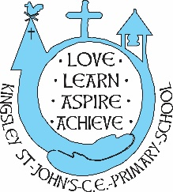

KSJ Fortnightly Flyer

*‘Believe in the light, whilst you have the light, so that you make become children of light.’*

John 12.36

Dear Parents/Carers,

Please find our fortnightly flyer, with our latest news.

**Christmas Charity Boxes**

This year we will be creating shoebox appeal packages for a new charity. Many thanks to Fliss Reeves for organising this. Curate Hilary will still collect Operation Christmas Child if you prefer to make these shoe boxes specifically.

Due to the cost of living crisis, some people may wish to contribute to a collective shoe box, rather than create a full shoe box for the charities. We will be taking donations from now for any items to contribute to a box and the school staff will work together to create shoe boxes with the donations.

**Welcomes and Goodbyes**

Welcome to our school family to…

George (Year 1) – brother to Reece and Max

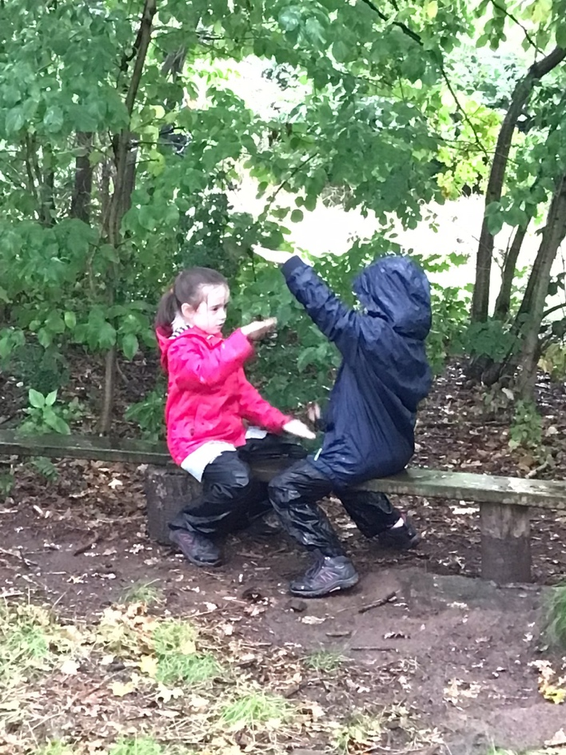

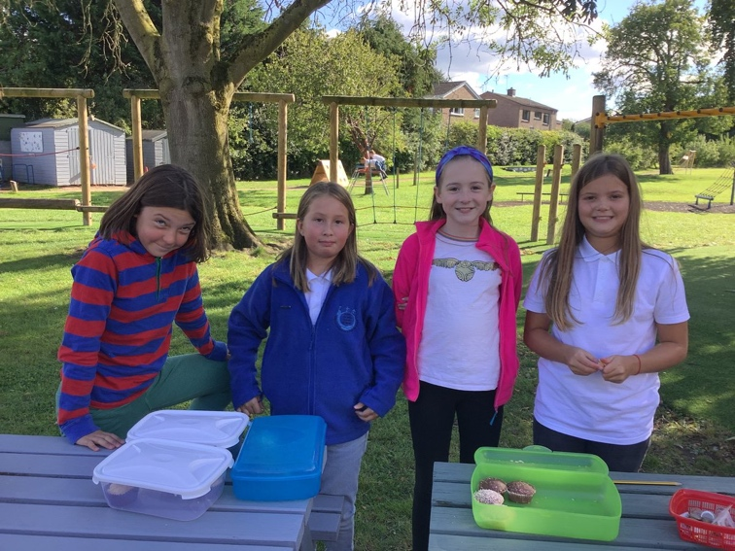

**Governor of the Month**

This year we will enjoy a Governor of the Month programme. September is the month for Jenny Williamson, mum to Matilda (now in Y7), Darcey (Y5) and Jack (Y2). Jenny will visit school in September to listen to some children read and look at our reading curriculum developments. October’s governor is Bruce Waddell.

**Sporting News**

Many thanks to Seb and Lyla-Mai who represented our school in the Dodgeball leadership this week. They are now fully trained and will look to support other children in school in their playtime team games.

Article 31 of the UN Convention of the Rights of the Child states that all children have the right to rest and leisure and enjoy recreational activities.

Mrs Byrne and the Sports Council have had their first meeting and are looking at ways to enhance playtime. More news as we get it…

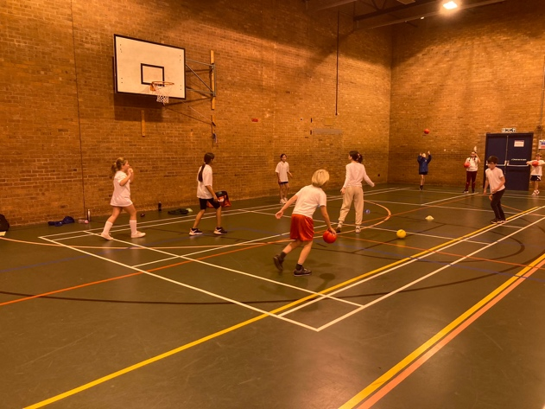

**Christmas Early Preparations**

Our Christmas Performance this year will be Countdown to Christmas. Early preparations are being made looking at roles in the play. As usual, there will be a pleasant mix of drama, song and dance. There will be no need for any parents to provide anything for the performance. Our provisional dates for the performances are December 5th – dress rehearsal pm, Tuesday 6th in the evening and Wednesday 7th in the afternoon.

Cauliflower Cards – one again we will be designing our own Christmas cards/wrapping paper and gifts. Your child will soon be bringing home their design and the instructions to carry out an order. The artwork will need to be returned by 1st November so that they can be delivered in time for Christmas. More information will come out nearer the time.

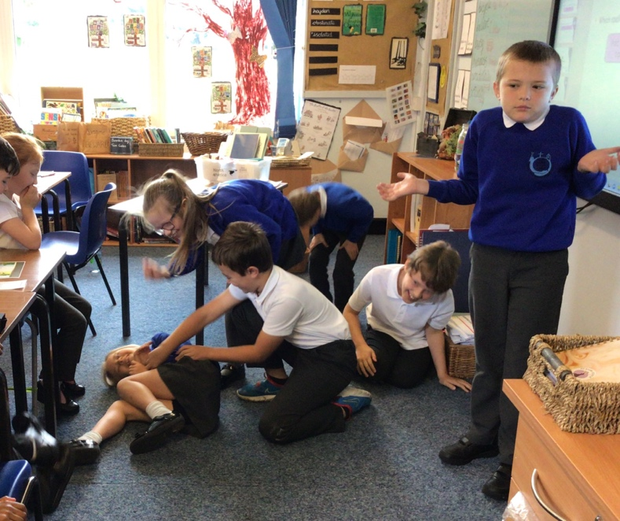

Contacting the Class teacher

Please remember that for any worries, concerns or difficulties you should contact the class teacher in the first instance. The emails are always available on the class page on the website, but added here for your information

Class 1 – [cowell@kingsleystjohns.co.uk](mailto:cowell@kingsleystjohns.co.uk) or [raynor@kingsleystjohns.co.uk](mailto:raynor@kingsleystjohns.co.uk)

Class 2 – [Byrne@kinglseystjohns.co.uk](mailto:Byrne@kinglseystjohns.co.uk)

Class 3 – [senco@kinglsey-st-johns.cheshire.sch.uk](mailto:senco@kinglsey-st-johns.cheshire.sch.uk)

Class 4 – [davies@kingsleystjohns.co.uk](mailto:davies@kingsleystjohns.co.uk)

**Enriching our Curriculum**

As you know, we are very proud, as a school, of the breadth of ways that we work to enhance and enrich our curriculum. Some further examples this term…

Class 3 will be visiting The Great Orme on Thursday 29th September.

Years 3 to 6 will have a visit to the cinema on Tuesday 22nd November

Mad Science – thank you for the really positive response to the club offer. This club will go ahead and will begin on the 8th November.

We are also delighted to be supporting FRIENDS in their community based activities – The KSJestival, Spooky Party and other ventures too.

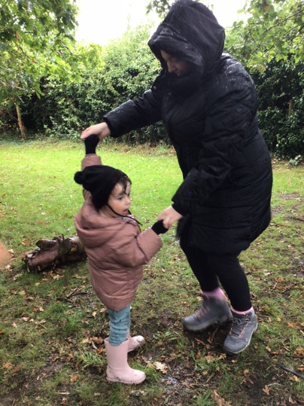

**Courageous Advocacy**

Well done to our Y6 girls who raised over £50 for the homeless and Ukraine through their impromptu cake stall. The Millionaire’s Shortbread was divine. It never ceases to amaze me how caring and considerate our children are for those disadvantaged in our world.

**Apples**

We have an abundance of apples in the school – We have eaters and cookers. Some children in school are picking them and we will leave them beside the gate for free if anyone wants to take some

We have an abundance of apples growing on our trees. Please do bring along a bag and pick some for your homes, of you would like. There are cookers and eaters – please take as many as you wish.

United Nations Convention for the Rights of the Child (UNCRC)

A year ago we started our journey to becoming a Rights Respecting School and successfully achieved our Bronze Award. As we work towards our Silver Award, we have re-affirmed our commitment to understanding and promoting the Charter of Children’s Rights. We have talked with the children about the Rights and also the responsibilities we have as citizens to ensure these rights are protected. September leads to our focus on Article 12 and 13 – The Right to have a Voice and be listened to. This is why we gove such importance to our responsibilities and roles throughout school.

Thank you for your continued support, trust and togetherness.