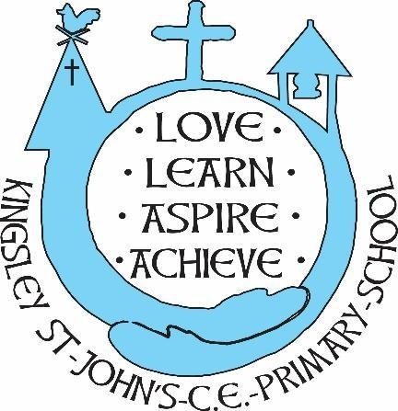
Kingsley St. John’s History Curriculum
We believe in God as the great creator of all things - earth, day and night, seas and oceans, animals and plants and mankind, in his own image. We believe that we all have that same seed of creativity within us and appreciate how God’s World has changed over time. At KSJ we nurture each and every seed. Regardless of background or vulnerability, our children are given all they need to grow, flourish and be the best that they can be.

Intent: What do we intend our pupils to learn?
At Kingsley St John’s we have a curriculum that is successfully adapted, designed and developed to include all our pupils. It is coherently planned and sequenced to embed knowledge and skills about local, British and world history. Our curriculum is sequenced in chronological order to enable our pupils to study history as a whole school narrative. This allows our pupils to transfer new knowledge and build on what has previously been taught.
Our history curriculum is knowledge, vocabulary and skills rich allowing for discovery learning. We inspire our pupils' curiosity to find out more about the past and ask perceptive questions, reporting their findings by drawing on skills from across the curriculum. Our pupils will study a range of cultures and historical perspectives allowing them to understand the complexities of people’s lives, the diversity of society and relationships between different groups and enabling them to be respectful and tolerant of our similarities and differences.
Our pupils will leave Kingsley St John’s being able to explain how history fits together, how key events and people from one time period affect another and make detailed links across features of past societies and different historical periods

● History is taught on a 2-year rolling programme based upon The National Curriculum.
- History is taught using an enquiry framework-need to know: use data: make sense and connections: reflect on learning
● Teachers create a positive attitude to historical learning within their classrooms;
● History will be taught in planned topics with working as a historian embedded in the approach.
● Children are encouraged to ask their own questions and be given opportunities to use their historical skills and research to discover the answers. This curiosity is celebrated within the classroom.
● Planning involves teachers creating engaging lessons, often involving high-quality resources to aid understanding of conceptual knowledge. Teachers use precise questioning in class to test conceptual knowledge and skills, and assess pupils regularly to identify those children with gaps in learning, so that all pupils keep up.
● We build upon the knowledge and skill development of the previous years. As the children’s knowledge and understanding increases, they become more proficient in applying these to enquiry based learning.
● Historical skills are embedded into lessons to ensure that skills are systematically developed throughout the children’s school career and new vocabulary and challenging concepts are introduced through direct teaching. This is developed through the years, in-keeping with the topics.
● Teachers demonstrate how to use source materials, artefacts, and skills in order to embed historical understanding.
- Teachers find opportunities to develop children’s understanding of the past by accessing outdoor learning and workshops with experts.
● Children are offered a wide range of extra-curricular activities, visits, trips and visitors to complement and broaden the curriculum. These are purposeful and link with the knowledge being taught in class.
● Regular events allow all pupils to come off-timetable, to provide broader provision and the acquisition and application of knowledge and skills.
● At the end of each topic, key knowledge is reviewed by the children and rigorously checked by the teacher and consolidated as necessary.
Implementation: How is history taught and assessed in order to build pupils knowledge and enable them to apply that knowledge as skills?
At Kingsley St John’s knowledge is seen as a springboard to acquiring more knowledge. Our history curriculum is designed to allow our pupils to develop their historical skills and vocabulary. Each key stage has a set of historical skills to ensure that our pupils as developing their skills as historians:
- understanding chronology and historical concepts,
- interpretation, enquiry and communication
Our units of work are designed to enable us to teach concepts in an appropriate order to support our pupils' understanding and build on previously taught knowledge and skills.

Golden threads
Our history curriculum is a 2-year rolling programme, reviewed yearly. We have adopted a ‘golden thread’ approach, a series of historical concepts which the pupils revisit over time accumulating and integrating knowledge into larger areas.

religion | Economy | Conflict | Leadership | Society
Worship  Afterlife  Belief  Priests  Pilgramage | Trade/Trade route  Resources  Rich/Poor/Peasantry  Slavery/Slaves | Power  Invasion/Invader  Conquer/Conquest  Military | Monarchy  King/queen/Emperor/leader  Power/control  Democracy  Laws and legislation  Crime and Punishment | Settlement  Migration  Empire/kingdom  Culture  Civilisation

Across the curriculum
We use high quality texts to support our history topics and enrich our wider curriculum. Each teacher provides a wide range of fiction and non-fiction texts in their class reading area to support pupil’s curiosity and learning. There is a guidance list of suggested texts to support learning across the history curriculum.
Curriculum Enrichment
Where possible each unit of work is enriched by a school trip or school visitor. For example, Class 2 visit Grosvenor museum to learn about changes within living memory and Weaver hall museum to experience the Great Fire of London whilst Class 3 take part in a life in the stone age day at school. Visitors from the local community have supported our whole school learning around Remembrance as we researched our village war memorial.

Impact: How do we know our history curriculum is effective?
At Kingsley St John’s we believe that if our pupils have become knowledgeable and effective historians they will be able to talk with knowledge and confidence on the range of topics studied, making connections and links between different time periods and how these links affect us. This is why pupil voice is such an important tool in measuring progress and impact
The work in our topic and curriculum books will be of a consistently high quality and will incorporate learning from other areas of the curriculum and our discovery curriculum.

- The practical approach at Kingsley St John’s results in a fun, engaging, high-quality historical education that provides children with the foundations and knowledge for understanding the world.
- Our engagement with the local area ensures that children learn through varied and first-hand experiences of the world around them.
- Through various workshops, trips and interactions with experts and local charities, children have the understanding how history has an effect on the way we live our lives today.
- Children at KSJ overwhelmingly enjoy history and this results in motivated learners with sound understanding of historical skills and concepts, ready for the next phase of their science learning.
- There is clear progression in knowledge, skills and understanding within history.
- Children are ready for the next stage of their education journey.

