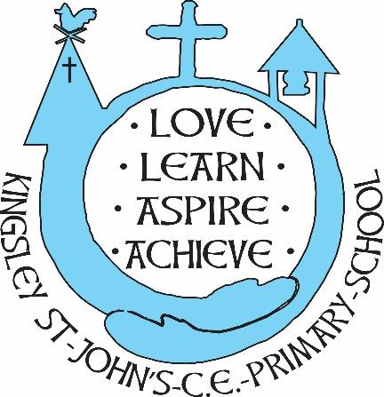
Kingsley St. John’s Reading Curriculum
We believe in God as the great creator of all things, and since God created mankind in his own image, we believe that we all have that same seed of creativity within us. At KSJ we nurture each and every seed. Regardless of background or vulnerability, our children are given all they need to grow, flourish and be the best that they can be.
Intent
Reading is a privilege and a powerful tool to broaden understanding and join up knowledge and thinking. At Kingsley St John’s we aim to inspire our children to enjoy reading, to know how to improve their own reading ability and to thrive in all learning through being an effective reader. The skills of reading are appreciated, and teachers discuss with the children their reading, their texts and drive that desire to read more. We are all readers. We aim to harness and nurture reading skills so that our children can read effectively different texts, to support their knowledge and learning across the curriculum.
We aim for all children:
- to read confidently across all genres
- to appreciate quality texts
- to identify the key features of different text types
- to build fluency and understanding of the text read
- to learn how to critically and constructively appraise the texts read
- to develop expression and understanding of grammar through reading effectively
- to be ready for the next stage of their learning journey
- to develop their independence of reading.
- to read and consider authorial language choices.
- To develop the higher order reading skills of inference and understanding.
- to develop the skills of scanning, skimming and reading for information.

Implementation
Reading is taught discretely at Kingsley St John’s as well as taught, rehearsed and embedded through close links alongside writing for different purposes. Reading is at the heart of our approach across the curriculum. By taking a text-based approach, we give the children the chance to develop culturally, emotionally, socially and spiritually, enabling them to both acquire knowledge and build on what they already know.
Early reading is taught through the teaching of phonics through a multi-sensory approach. Phonics is organised through Letters and Sounds. Lessons are supported through bringing in quality resources and equipment from other phonics companies, such as Jolly Phonics. See phonics curriculum for more details. Individual reading is supported through quality reading texts, which are organised to allow progression to be tracked. Books are very closely linked to phonics phases as well as following the benchmarking reading organisation.
Free read (KS2 generally) books are organised through the accelerated reading programme so that children’s choices can be monitored to ensure challenge and progression is evident and children do not coast.
Guided Reading is taught across the school. Planning is balanced between whole class guided reading, explicitly teaching higher order reading skills, such as inference, or complex dedication, and group guided reading, with no more than 6 pupils in a group, with a targeted level text to ensure challenge in reading fluency, and effective understanding. All pupils have a reading diary to log their reading progress. These provide effective communication between school and home so that there is a consistency and children are able to revisit. The school marking code is used to support learning so pupils recognise their strengths and next steps of learning within reading. CHildren at risk of falling behind their peers, or expected levels are identified early and interventions, booster reading are implemented.
Reading is assessed using Lexplore eye tracker 3 times a year as well as more formal reading assessments using Rising Stars Reading at age related levels. These inform teacher planning and the provision map for interventions. They are analysed by the class teacher and SLT each term.
All classes have a class text which is chosen in consultation with the pupils, this is focused upon enjoying being read to, the joy of reading and is treated as a very special time in class, to share a text.

Impact
Children enjoy reading and demonstrate inspiration and motivation for selecting their next book.
Reading is appreciated by all members of our school family.
Children leave KSJ ready for the next stage of their learning as secure readers.
Children are able to talk about what they have read.
Children are secure in their phonic knowledge and can apply these skills to become fluent readers.
Children can read a range of genres effectively and retrieve important knowledge/information.
Reading skills are embedded and secure at their level and ready for the next stage of learning.

