# School Holidays during School Closure

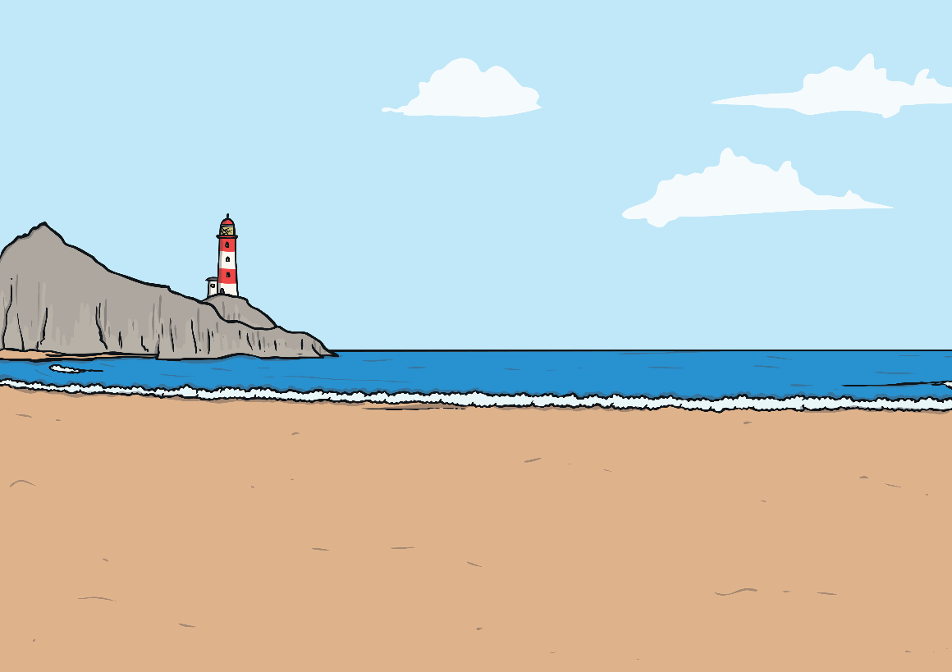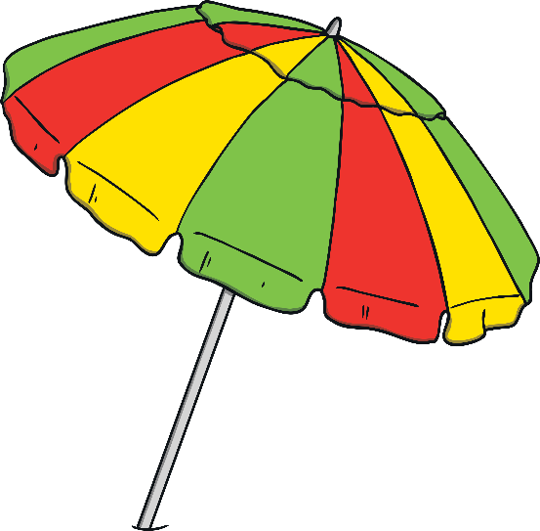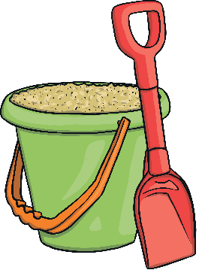

My name is _____ and I am in year __ at Holy Family school.

Every school in England has time when the children do not go to school. This is called the school holidays.

The time off in the school holidays is different each time. It could be a week, two weeks or six weeks. The six-week holiday is usually in the summer. The two week holiday happens at Easter and at Christmas.

Today is the last day before the Easter holidays. These will last for two weeks.

Having time off in the holidays is good as this gives me time to relax.

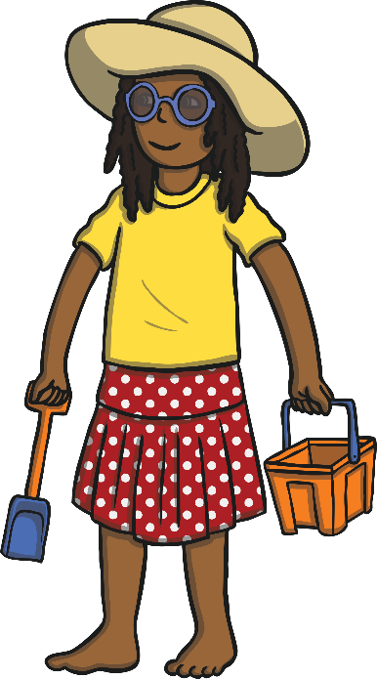

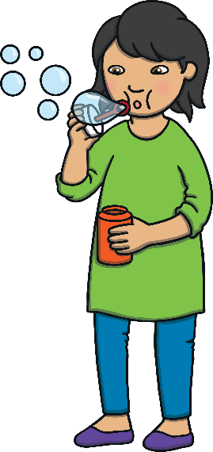

In the school holidays I can do nice things. Usually I can play with my friends, spend time with my family, go on walks or visit new places.

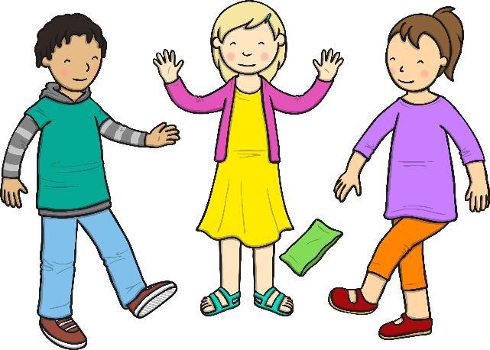

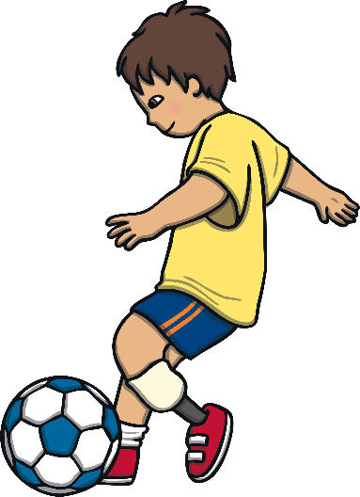

At the moment, we aren’t allowed to go out and see other people so I can do nice things with the people in my house instead. We are allowed to go for nice walks, I can do this and look out for rainbows and teddy bears in people’s windows.

Because we are learning from home at the moment, it might be confusing to stop working for two weeks and then start again when the holidays are over. Mummy or Daddy can help with this by making me a calendar or a visual chart to show me when it is time to go back to home learning.

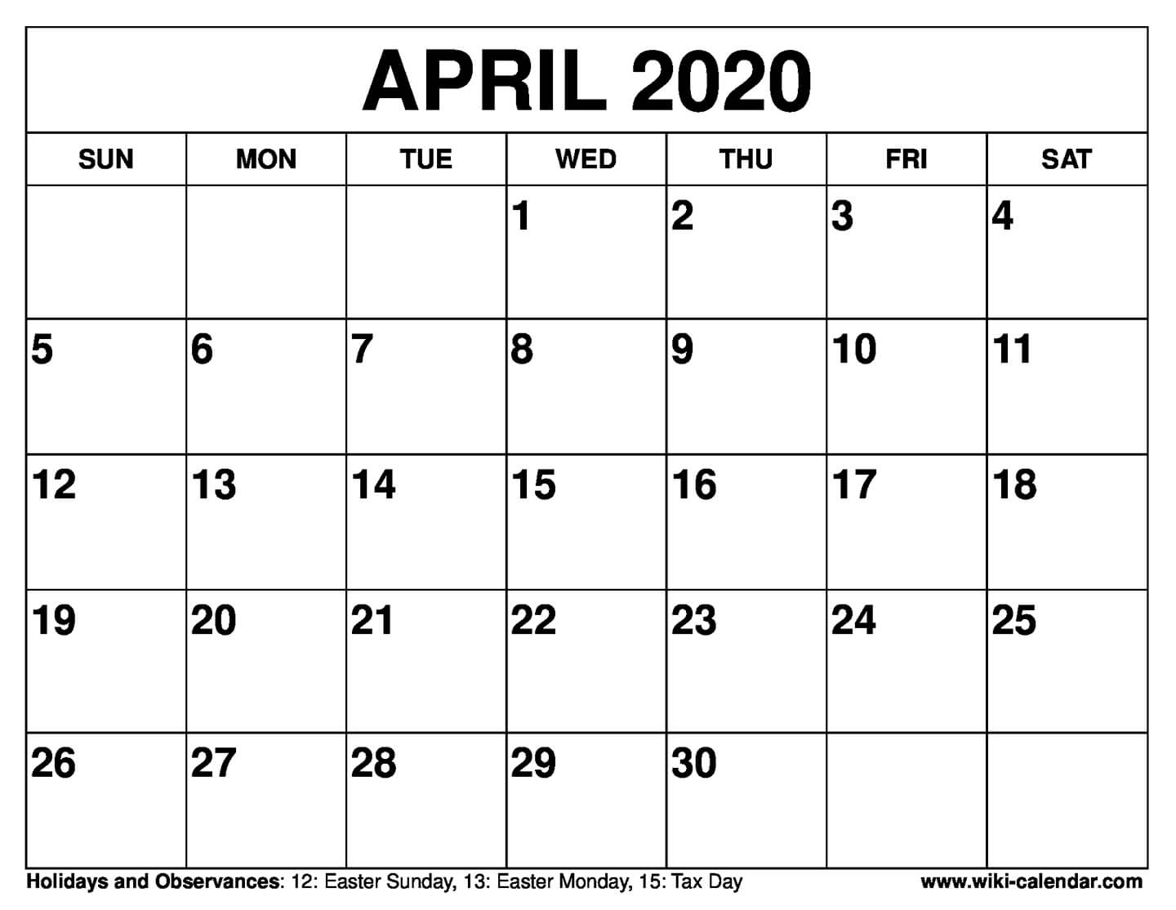

Here I can write down some of the fun things I have done over Easter, and some of the home learning I am looking forward to getting back to!