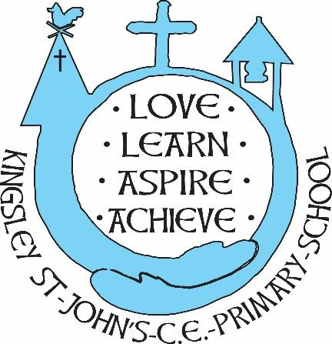
Kingsley St. John’s Physical Education Curriculum
We believe in God as the great creator of all things - earth, day and night, seas and oceans, animals and plants and mankind, in his own image. We believe that we all have that same seed of creativity within us. At KSJ we nurture each and every seed. Regardless of background or vulnerability, our children are given all they need to grow, flourish and be the best that they can be.
Intent
At Kingsley St John’s CE Aided Primary School, we want our children to be able to explore a physical education curriculum with an open, positive mind. We want our curriculum to inspire all children to succeed and excel in competitive sport and other physical activities. We want our children of Kingsley to experience this in a safe and supportive environment, allowing the children to attain optimum physical and emotional development. We intend to deliver high-quality teaching and learning opportunities that inspire all children, regardless of abilities, to succeed in physical education and in developing life skills. We also want to teach children how to cooperate and collaborate with others as part of an effective team, understanding fairness and equity of play to embed life-long values. Our curriculum aims to improve the wellbeing and fitness of all children, not only through the sporting skills taught, but through the underpinning values and disciplines PE promotes.
PE will allow our children to:
- Explore new skills and knowledge in different sports
- Learn about health (physical and mental) and the importance of it
- To allow themselves to find a new hobby/talent
- To gain skills and character strengths that they will keep for later in life
- To express themselves through a sport/movement

Implementation
- PE is taught on a 2-year rolling programme based upon The National Curriculum. We use ‘Complete PE’ for lesson planning, ideas, resources, and assessment
- Teachers create a positive attitude towards being physical in and out of the classroom
- PE at Kingsley St John’s provides challenging and enjoyable learning through a range of sporting activities including invasion games, net & wall games, strike and field games, gymnastics, dance, swimming and outdoor & adventure.
- Pupils participate in high quality PE lessons each week, covering two sporting disciplines every half term.
- Children are encouraged to participate in the varied range of extra-curricular activities. Lunch time and after school clubs are available for the children
- We have an outside agency to deliver high quality sport clubs
- Children are invited to attend competitive sporting events within the local area. This is an inclusive approach which endeavours to encourage not only physical development but also mental well-being. These events also develop teamwork and leadership skills and are very much enjoyed by the children.
- Children have the chance to become a sport leader- this allows children to have the chance to explore a sport and be able to develop the skills to deliver their own clubs
- KS2 children attend swimming lessons swim once a week for 10 weeks. We repeat the 10-week course later for any children that are still unable to swim.
- ‘YourTrak’ app- every class set up to use- tracking the laps of the circuit in an enjoyable way as well as children having the chance to take a break mentally whilst getting exercise
- We have a sports council that include children from Year 1 to Year 6. This group enables children to have an active role in decisions regarding health and well-being activities, as well as whole school celebrations

Impact
All children at Kingsley St John’s receive a broad and balanced PE curriculum regardless of year group, gender, or ability. Teachers plan PE lessons using our clear progression of skills and knowledge that we have devised as part of our curriculum. This enables children to receive age-appropriate skills. Taking part in competitions and festivals allow our children to have opportunities and different experiences outside of school. It allows them to put their new skills or talent into something different whether that be competitive or non-competitive. We want to motivate children to participate in a variety of sports through quality teaching that is engaging and fun. We equip our children with the necessary skills and a love for sport. They will hopefully grow up to live happy and healthy lives utilising the skills and knowledge acquired through PE.

