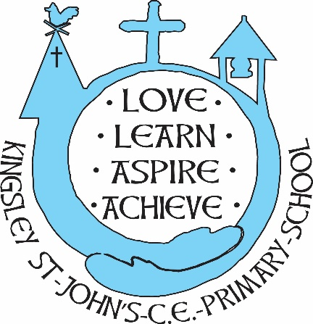
Kingsley St. John’s Art and Design Curriculum
We believe in God as the great creator of all things, and since God created mankind in his own image, we believe that we all have that same seed of creativity within us. At KSJ we nurture each and every seed. Regardless of background or vulnerability, our children are given all they need to grow, flourish and be the best that they can be.
Intent
At Kingsley St. John’s Art and Design is not simply a means to an end…or an elaborate display, it is a process that involves not only learning and progressing skills and techniques, but also taking risks and experimenting. Our children have the opportunity to try new things, experiment with their ideas, express themselves and find their own sense of style. We have built a curriculum that is exciting, fires the imagination, encourages innovation and is embedded into all areas of our curriculum from English to Science, Maths and beyond.
Our children use all they have learnt and are inspired to make imaginative, creative and individual pieces of art. They:
- are given the opportunity to experience and experiment with a wide range of media
- learn and develop a variety of artistic skills and techniques
- are able to understand and appreciate art, craft and design, where it comes from, who makes it and how it is made
- are able to describe their own work, and the work of others, using appropriate vocabulary
- make reasoned choices about the materials and techniques they will use
- are able to evaluate their own work and the work of others stating their preferences and the reasoning behind them

Implementation
- High quality, purposeful lessons are planned collaboratively to include and enhance all areas of the wider curriculum
- Skills and knowledge are built, developed and practiced year on year with progression evident in sketch books, wider work and displays
- Lessons include time to warm up and prepare as well as carefully modelled instruction combined with independent research and exploration.
- Children’s learning is supported by the use of a wide range of high quality resources
- Children create mixture of individual, small group and class pieces
- Artists and experts are invited into school to share their knowledge and experience as well as children participating in off site visits to broaden their experience of art in a wider context
- Engagement with the local community through collaborative events and the display of children’s work in community spaces such as church and local art galleries.
- Children have the opportunity to engage in the Arts Award programme.

Impact
Whether a child is creating an accurate scientific drawing, exploring 3D shape or expressing their emotions through abstract painting, at Kingsley St. John’s our children will become creative learners, using their skills and imagination for many purposes, each just as important as the next.
- Children will see the way art and design contribute to and reflect history and culture, their own and that of others worldwide.
- Through art our children will develop their ability to evaluate, edit and improve their work, an essential and transferable skill resulting not only in innovative and exciting art work but improvement across all learning.
- We will celebrate their creativity and individuality, ensuring the children feel the value of their work and the process of creating it
- The ability to express themselves and their emotions through art will support children’s mental health and well-being, giving them a creative outlet and opportunities for self-reflection.

Nothing ventured, nothing gained: A note on risk and experimentation
“For children to get the most out of drawing, they need to be encouraged to push beyond what they consider ‘safe’ (safe drawings are those in which we know what the outcome is going to be before we have even started making them) and take risks”
Paula Briggs – Co-founder of AccessArt and author of Drawing Projects for Children
We could replace the word ‘drawing’ with ‘art’ in the sentence above and it would be just as relevant. ‘Safe’ work has its place in the art room and should not be dismissed, but children will never truly get a ‘feel’ for the materials, tools and techniques at their disposal unless they are given the chance to experiment with them and take risks. When it comes to design, a child cannot plan a piece of work well if they have no experience of the medium that they are expected to use.
We should try and discourage a ‘right or wrong’ mind-set when we are being creative, perhaps something has not gone according to plan, so:
- How is it different to what you imagined?
- Perhaps it is as good as, or even better than, your original idea?
- Could you modify it in some way?
- What would you do differently next time?
- Can you work on this way of drawing/painting etc. and create a new style/piece of artwork?
Here, sketchbooks are invaluable, they are places to try and then modify ideas and techniques, evaluate and then, try again.
We should not measure success in art solely on the finished product. Children need to be shown, and feel the value of, the process they have gone through to create a piece of art they can be proud of.

