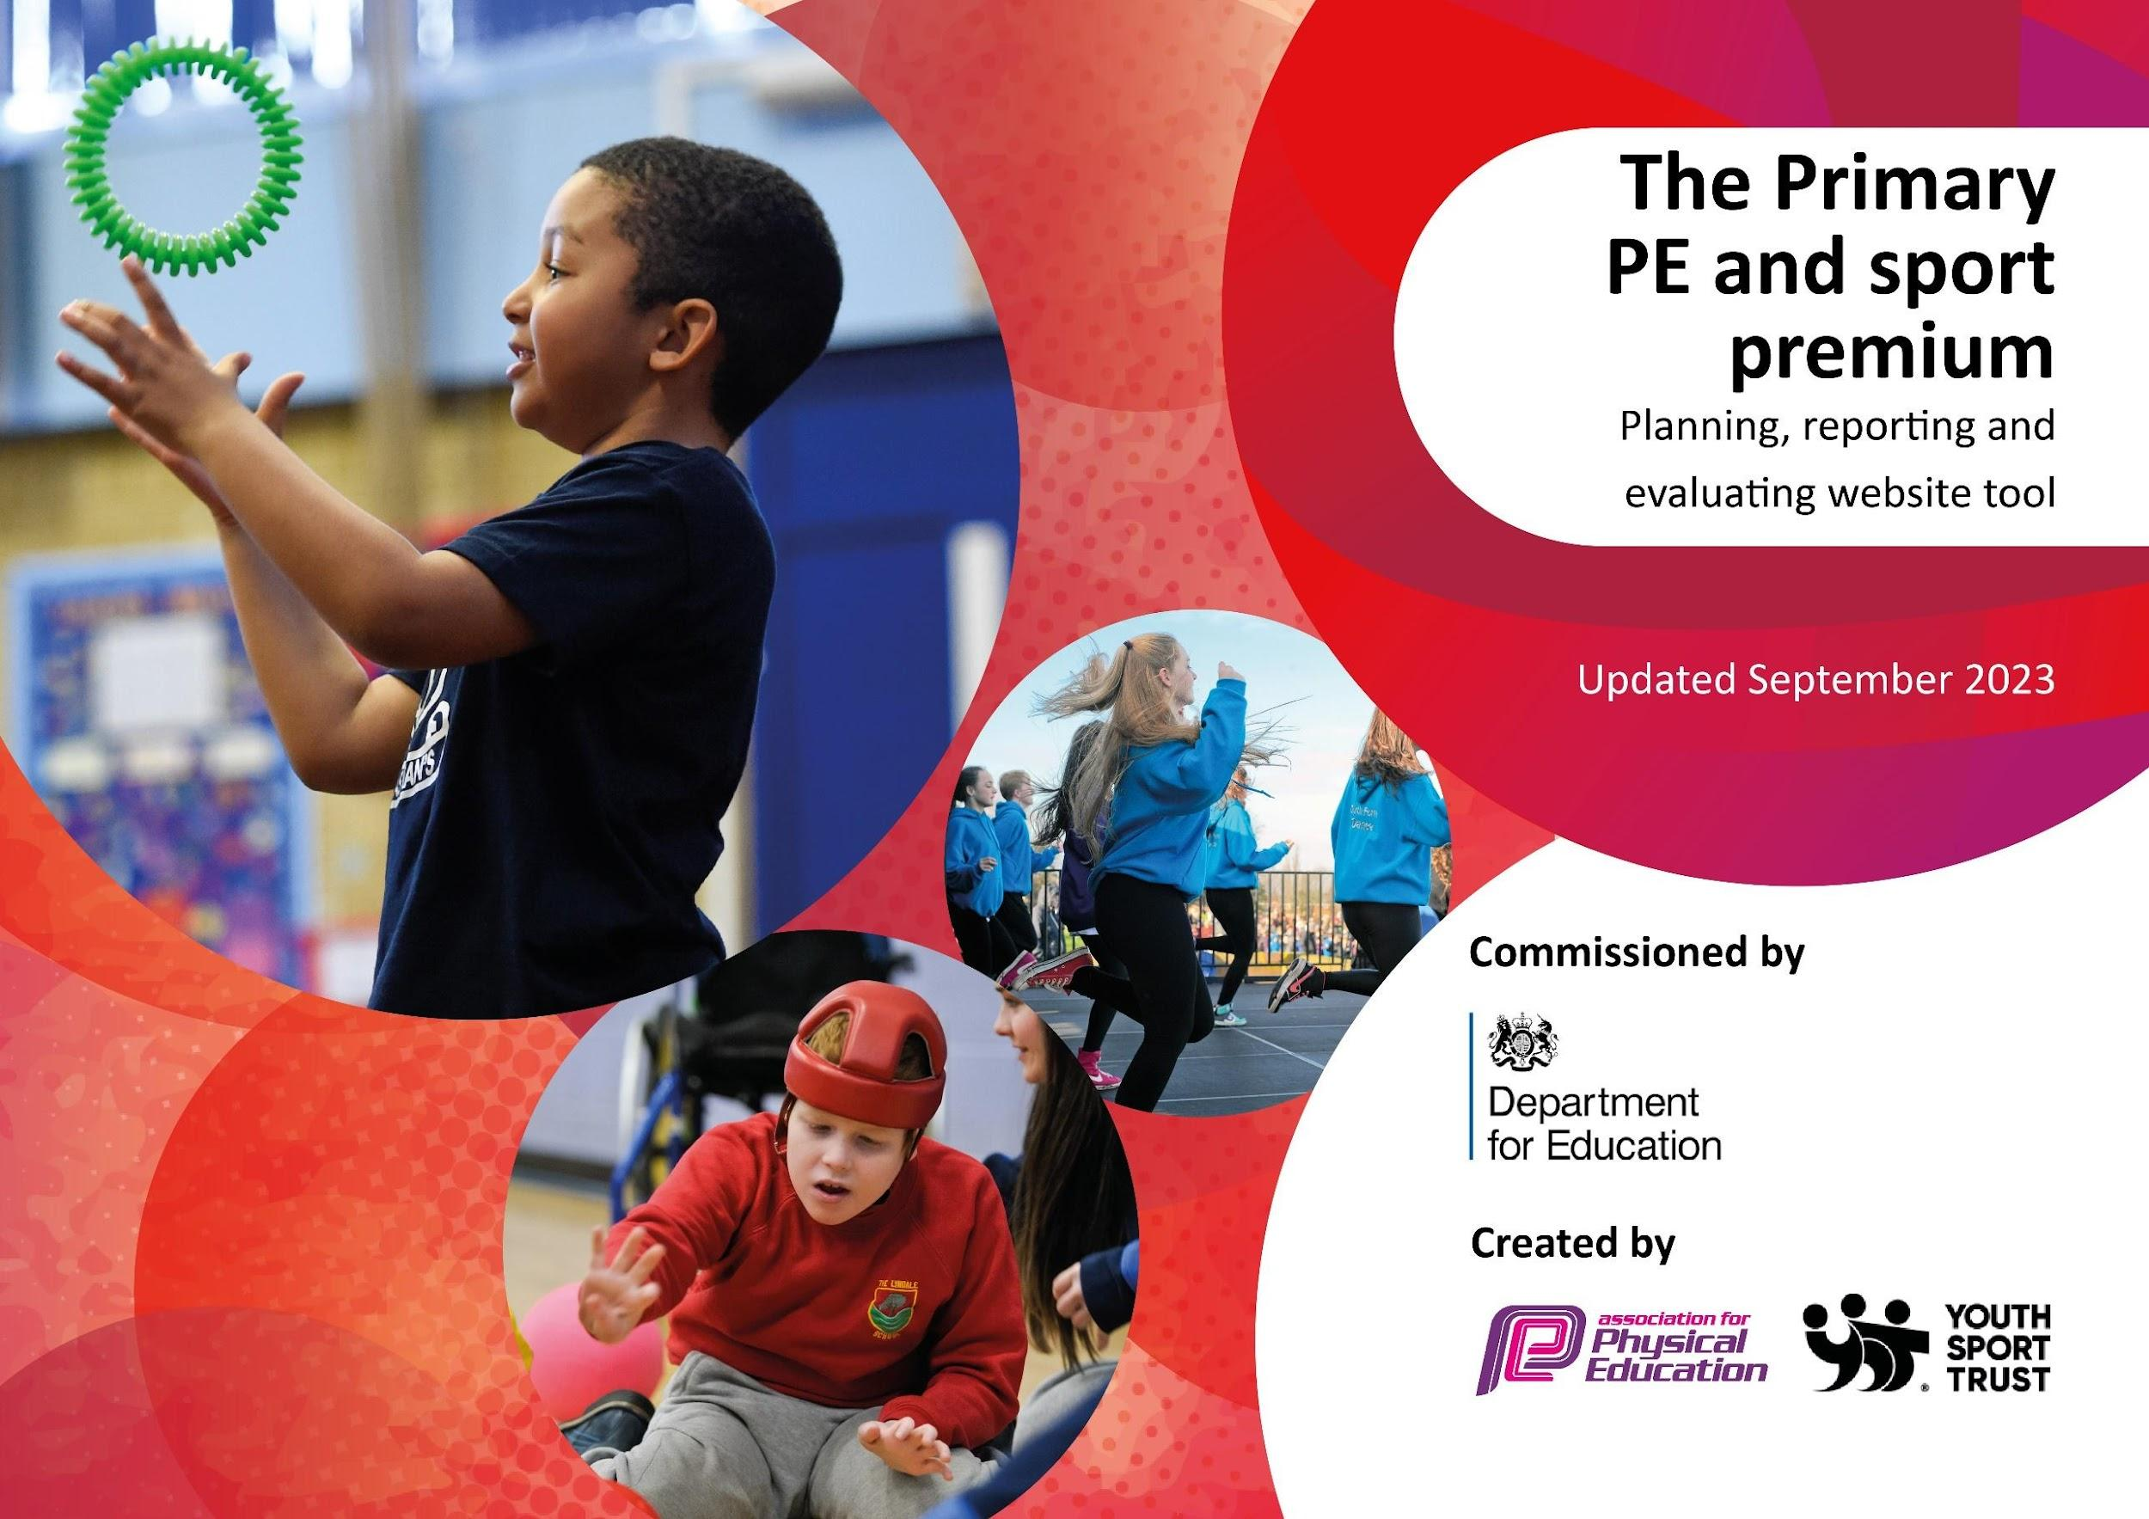

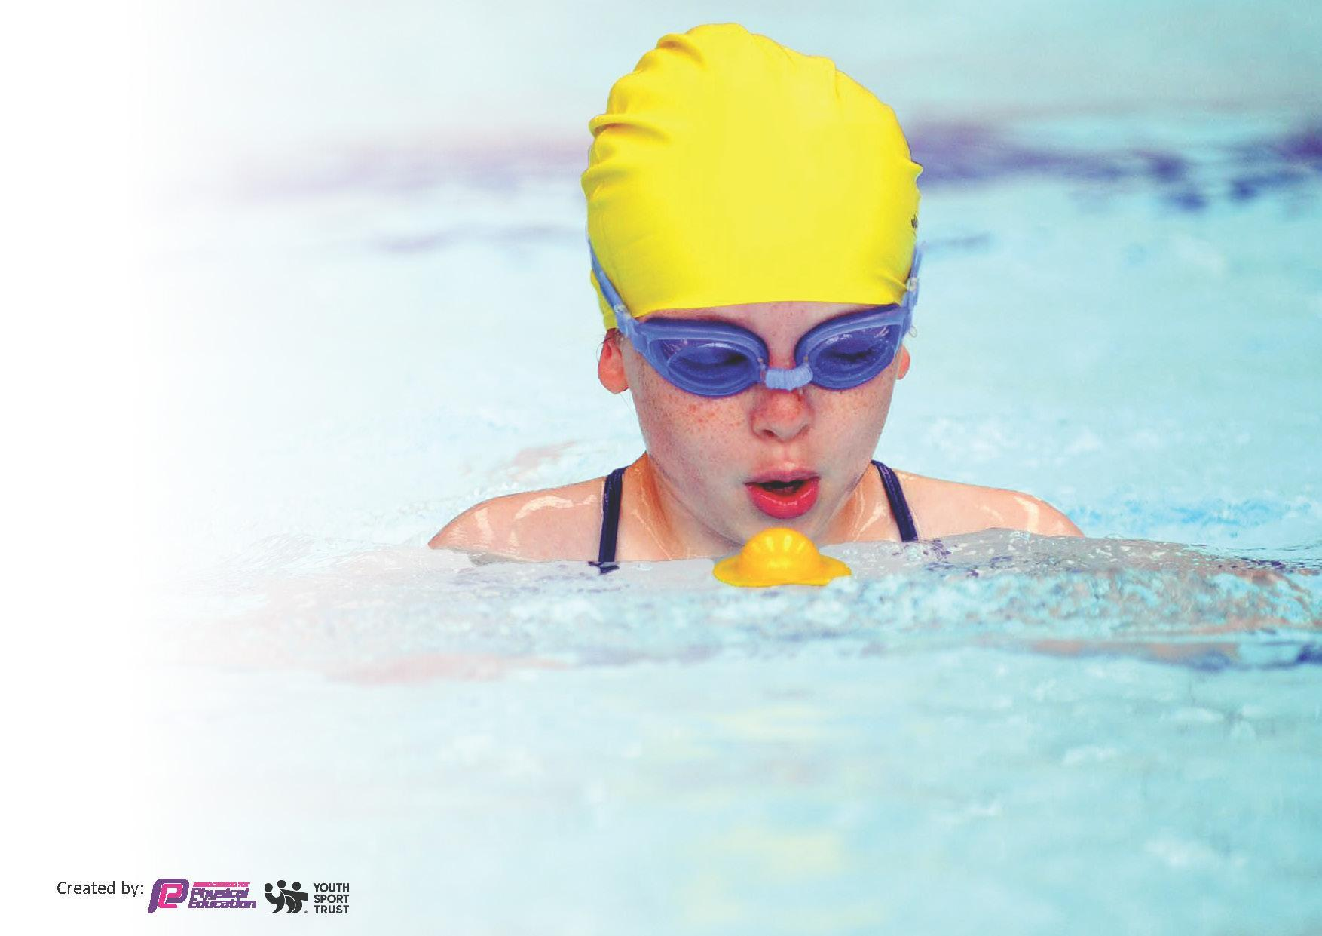
This template can be used for multiple purposes:
by:
- It enables schools to effectively plan their use of the Primary PE and sport premium
- It helps schools to meet the requirements (as set out in guidance) to publish information on their Primary PE and sport premium
- It will be an effective document to support Ofsted inspections enabling schools to evidence progress in Physical Education (PE) and evidence swimming attainment, which forms part of the PE National Curriculum. We would recommend schools consider
the Intent, Implementation and Impact of any spend, as examined within the Education Inspection Framework.

It is important that your grant is used effectively and based on school need.

Schools must use the funding to make additional and sustainable
improvements to the quality of the PE, School Sport and Physical Activity (PESSPA)
they offer. This means that you should use the Primary PE and sport premium to:

- Build capacity and capability within the school to ensure that improvements made now will benefit pupils joining the school in future years
- Develop or add to the PESSPA activities that your school already offers.

The Primary PE and sport premium should not be used to fund capital spend projects; the school’s core budget should fund these. Further detail on capital expenditure can be found in the updated Primary PE and sport premium guidance.

The Primary PE and sport premium guidance, outlines 5 key priorities that funding should be used towards. It is not
necessary that spending has to meet all the key priorities, you should select the priorities that you aim to use any funding towards.

Although completing this template is not a requirement for schools, schools are required to publish details of how they spend this funding. Schools must also outline what the impact this funding has had on pupils’ PE and sport participation and attainment and how any spending will be sustainable in the future. All funding must be spent by 31st July 2024.

The Department for Education has worked closely with the Association for Physical Education (afPE) and the Youth Sport Trust (YST) to develop this template and encourages schools to use it. This template is an effective way of meeting the reporting requirements of the Primary PE and sport premium.
Review of last year’s spend and key achievements (2022/2023)

We recommend you start by reflecting on the impact of current provision and reviewing your previous spend.

Activity/Action | Impact | Comments
This is all on the old format.
Key priorities and Planning
This planning template will allow schools to accurately plan their spending.

Action – what are you planning to do | Who does this action impact? | Key indicator to meet | Impacts and how sustainability will be achieved? | Cost linked to the action
New equipment for play times (and for after school extracurricular activities)  FDP coaching- after school  New equipment for PE lessons  Transport for competitions to increase participation for all children  To use Mandy for planning and running of competitions within school  Attend as many competitions as possible – ranging from red group to blue group (FAVSP timetable)  To increase adult confidence in delivering games at play times/lunch times- use Mandy for training?  Renew Complete PE  Yourtrak app | Children- they will be using the equipment for their games  Adults- they will be using them to set games during play times  Children- they are the ones taking part in the club  Children and staff – they are the ones using the equipment for their lessons and learning  Children – they are the ones travelling to the competition  Adults in school- they are the ones who sort out their cars in order to travel with the children  Children and adults as they will be the ones involved when Mandy comes in to school  Children- they are the ones taking part  Children- they are the ones playing the games and are involved in the event at that time  Adults- they are the ones who are with the children at these particular times  Children- it is for their learning and progress  Adults- it is them who are using the platform for their planning and delivering of lessons  Children and adults- they are the ones using the app | Key indicator 2- the engagement of all pupils in regular physical activity- Chief Medical Officers guidelines recommend that primary school pupils undertake at least 30 minutes of physical activity a day in school  Key indicator 4- broader experience of a range of sports and activities offered to all pupils  Key indicator 4- broader experience of a range of sports and activities offered to all pupils  Key indicator 5- increased participation in competitive sport  Key indicator 2- the engagement of all pupils in regular physical activity- Chief Medical Officers guidelines recommend that primary school pupils undertake at least 30 minutes of physical activity a day in school  Key indicator 4- broader experience of a range of sports and activities offered to all pupils  Key indicator 3- the profile of PE and sport is raised across the school as tool for whole- school improvement  Key indicator 4- broader experience of a range of sports and activities offered to all pupils  Key indicator 5- increased participation in competitive sport  Key indicator 1- increased confidence, knowledge and skills of all staff in teaching PE and sport  Key indicator 4- broader experience of a range of sports and activities offered to all pupils  Key indicator 5- increased participation in competitive sport  Key indicator 4- broader experience of a range of sports and activities offered to all pupils  Key indicator 5- increased participation in competitive sport  Key indicator 1- increased confidence, knowledge and skills of all staff in teaching PE and sport  Key indicator 2- the engagement of all pupils in regular physical activity- Chief Medical Officers guidelines recommend that primary school pupils undertake at least 30 minutes of physical activity a day in school  Key indicator 3- the profile of PE and sport is raised across the school as tool for whole- school improvement  Key indicator 4- broader experience of a range of sports and activities offered to all pupils  Key indicator 1- increased confidence, knowledge and skills of all staff in teaching PE and sport  Key indicator 3- the profile of PE and sport is raised across the school as tool for whole- school improvement  Key indicator 2- the engagement of all pupils in regular physical activity- Chief Medical Officers guidelines recommend that primary school pupils undertake at least 30 minutes of physical activity a day in school  Key indicator 3- the profile of PE and sport is raised across the school as tool for whole- school improvement | Children- allowing them to use a variety of equipment to enable movement and imagination within their sporting games- sports council/play leaders will be in charge in keeping equipment tidied away  Children- high quality delivery of a specific sport and skills  Children and staff – high quality equipment – setting a standard for the children that PE/sport is important and they can see that through the equipment  Children – enables more children to take part in the sporting events- children who do not usually get the chance to. Having a coach means all the children know exactly how they are getting there rather than wondering whose car they are going to go in.  Adults in school- it takes the pressure off driving the children- organisation is easier – less impact on school as teachers do not cover for leaving to take the children.  Children- enables them to take part in a variety of skills and sports- allowing them to have healthy competition- allowing them to use skills they have learnt within PE lessons and putting them into a competition event  Adults- this will enable staff to see how Mandy delivers skills to the children as well as making the rules of the sport into a fun environment for them all.  Children- variety of sport in a healthy competition environment  Children- accessing sport/games/movement in a safe and controlled way  Adults- to help with behaviour at break/lunch times  Children – high quality resources and lessons for their learning  Adults- planning, videos and resources to allow them to deliver high quality PE lessons to our children  Interactive for the children to keep them engaged  Adults- a good way of tracking for all the children- can see if any child/ren need help or a little encouragement | Equipment (on a whole)- £3000  £300  £1000  £2750  £150

Key achievements 2023-2024
This template will be completed at the end of the academic year and will showcase the key achievements schools have made with their Primary PE and sport premium spending.

Activity/Action | Impact | Comments

Swimming Data
Meeting National Curriculum requirements for swimming and water safety.
Priority should always be given to ensuring that pupils can perform safe self-rescue even if they do not fully meet the first two requirements of the National Curriculum programme of study

Question | Stats: | Further context  Relative to local challenges
What percentage of your current Year 6 cohort can swim competently, confidently and proficiently over a distance of at least 25 metres? | % | Use this text box to give further context behind the percentage.  e.g., 30% - we are struggling to get pool space due to our local pool closing so we have had to use a much smaller local school pool. We have had to limit the number of pupils attending swimming lessons during one term which means some pupils have attended fewer swimming lessons than others.
What percentage of your current Year 6 cohort can use a range of strokes effectively [for example, front crawl, backstroke, and breaststroke]? | % | Use this text box to give further context behind the percentage.  e.g., Even though your pupils may swim in another year please report on their attainment on leaving primary school at the end of the summer term 2024

What percentage of your current Year 6 cohort are able to perform safe self-rescue in different water-based situations? | % | Use this text box to give further context behind the percentage.
If your schools swimming data is below national expectation, you can choose to use the Primary PE and sport premium to provide additional top-up sessions for those pupils that did not meet National Curriculum  requirements after the completion of core lessons. Have you done this? | Yes/No
Have you provided CPD to improve the knowledge and confidence of staff to be able to teach swimming and water safety? | Yes/No

Signed off by:

Head Teacher: | (Name)
Subject Leader or the individual responsible for the Primary PE and sport premium: | (Name and Job Title)
Governor: | (Name and Role)
Date:

