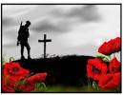
Remembrance Day
Swaying gracefully,
Remembering the soldier
Who gave us his life
To save our great Britannia
We show our thanks on this day.

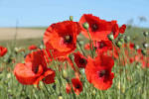
Poppies
Poppies oh poppies
We hear you calling their names
Poppies oh poppies .

By Amber

