pOPPIES
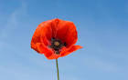
Beautiful poppies
Gazing along the field dull
Making a blanket
Over the battlefield
Poppies remind us of war

by Kate

